

NEHRU COLLEGE OF ENGINEERING AND RESEARCH CENTRE
(NAAC Accredited)
(Approved by AICTE, Affiliated to APJ Abdul Kalam Technological University, Kerala)

DEPARTMENT OF COMPUTER SCIENCE AND ENGINEERING
COURSE MATERIALS

EST 130 BASICS OF ELECTRONICS ENGINEERING
VISION OF THE INSTITUTION
To mould true citizens who are millennium leaders and catalysts of change through excellence in education.
MISSION OF THE INSTITUTION
NCERC is committed to transform itself into a center of excellence in Learning and Research in Engineering and Frontier Technology and to impart quality education to mould technically competent citizens with moral integrity, social commitment and ethical values.

We intend to facilitate our students to assimilate the latest technological know-how and to imbibe discipline, culture and spiritually, and to mould them in to technological giants, dedicated research scientists and intellectual leaders of the country who can spread the beams of light and happiness among the poor and the underprivileged.

ABOUT DEPARTMENT
- Established in: 2002
- Course offered : B.Tech in Computer Science and Engineering
M.Tech in Computer Science and Engineering
M.Tech in Cyber Security
- Approved by AICTE New Delhi and Accredited by NAAC
- Affiliated A P J Abdul Kalam Technological University.

DEPARTMENT VISION
Producing Highly Competent, Innovative and Ethical Computer Science and Engineering Professionals to facilitate continuous technological advancement.

DEPARTMENT MISSION
- To Impart Quality Education by creative Teaching Learning Process
- To Promote cutting-edge Research and Development Process to solve real world problems with emerging technologies.
- To Inculcate Entrepreneurship Skills among Students.
- To cultivate Moral and Ethical Values in their Profession.

PROGRAMME EDUCATIONAL OBJECTIVES
PEO1: Graduates will be able to Work and Contribute in the domains of Computer Science and Engineering through lifelong learning.
PEO2: Graduates will be able to Analyse, design and development of novel Software Packages, Web Services, System Tools and Components as per needs and specifications.
PEO3: Graduates will be able to demonstrate their ability to adapt to a rapidly changing environment by learning and applying new technologies.
PEO4: Graduates will be able to adopt ethical attitudes, exhibit effective communication skills, Teamworkand leadership qualities.

PROGRAM OUTCOMES (POS)
Engineering Graduates will be able to:
- Engineering knowledge: Apply the knowledge of mathematics, science, engineering fundamentals, and an engineering specialization to the solution of complex engineering problems.
- Problem analysis: Identify, formulate, review research literature, and analyze complex engineering problems reaching substantiated conclusions using first principles of mathematics, natural sciences, and engineering sciences.
- Design/development of solutions: Design solutions for complex engineering problems and design system components or processes that meet the specified needs with appropriate consideration for the public health and safety, and the cultural, societal, and environmental considerations.
- Conduct investigations of complex problems: Use research-based knowledge and research methods including design of experiments, analysis and interpretation of data, and synthesis of the information to provide valid conclusions.
- Modern tool usage: Create, select, and apply appropriate techniques, resources, and modern engineering and IT tools including prediction and modeling to complex engineering activities with an understanding of the limitations.
- The engineer and society: Apply reasoning informed by the contextual knowledge to assess societal, health, safety, legal and cultural issues and the consequent responsibilities relevant to the professional engineering practice.
- Environment and sustainability: Understand the impact of the professional engineering solutions in societal and environmental contexts, and demonstrate the knowledge of, and need for sustainable development.
- Ethics: Apply ethical principles and commit to professional ethics and responsibilities and norms of the engineering practice.
- Individual and team work: Function effectively as an individual, and as a member or leader in diverse teams, and in multidisciplinary settings.
- Communication: Communicate effectively on complex engineering activities with the engineering community and with society at large, such as, being able to comprehend and write effective reports and design documentation, make effective presentations, and give and receive clear instructions.
- Project management and finance: Demonstrate knowledge and understanding of the engineering and management principles and apply these to one’s own work, as a member and leader in a team, to manage projects and in multidisciplinary environments.
- Life-long learning: Recognize the need for, and have the preparation and ability to engage in independent and life-long learning in the broadest context of technological change.
PROGRAM SPECIFIC OUTCOMES (PSO)
PSO1: Ability to Formulate and Simulate Innovative Ideas to provide software solutions for Real-time Problems and to investigate for its future scope.

PSO2: Ability to learn and apply various methodologies for facilitating development of high quality
System Software Tools and Efficient Web Design Models with a focus on performance optimization.

PSO3: Ability to inculcate the Knowledge for developing Codes and integrating hardware/software
products in the domains of Big Data Analytics, Web Applications and Mobile Apps to create innovative career path and for the socially relevant issues.

COURSE OUTCOMES

CO1 | Demonstrate the knowledge of fundamental concepts in graph theory, including properties and characterization of graphs.
CO2 | Demonstrate the fundamental theorems on Eulerian and Hamiltonian graphs.
CO3 | Demonstrate the properties and characterization of trees. Illustrate the working of Prim’s and Kruskal’s algorithms for finding minimum cost spanning tree.
CO4 | Explain planar graphs, their properties and an application for planar graphs.
CO5 | Illustrate how one can represent a graph in a computer.
CO6 | Develop the efficient algorithms for graph related problems in different domains of engineering and science.

MAPPING OF COURSE OUTCOMES WITH PROGRAM OUTCOMES

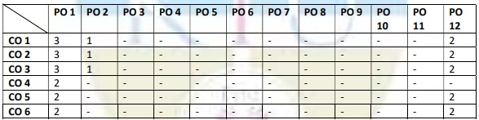
Note: H-Highly correlated=3, M-Medium correlated=2, L-Less correlated=1

PSO MAPPINGS ALSO NEEDS TO INCLUDE

SYLLABUS
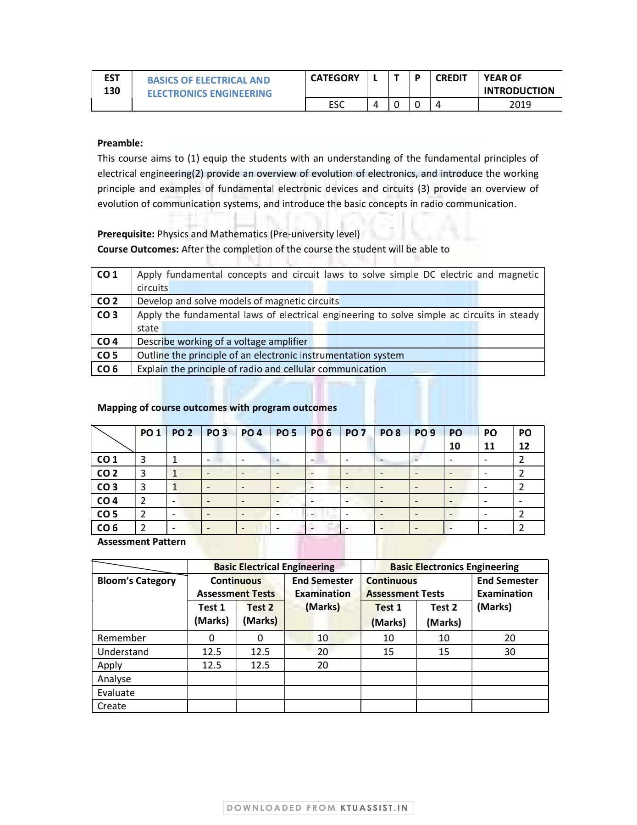




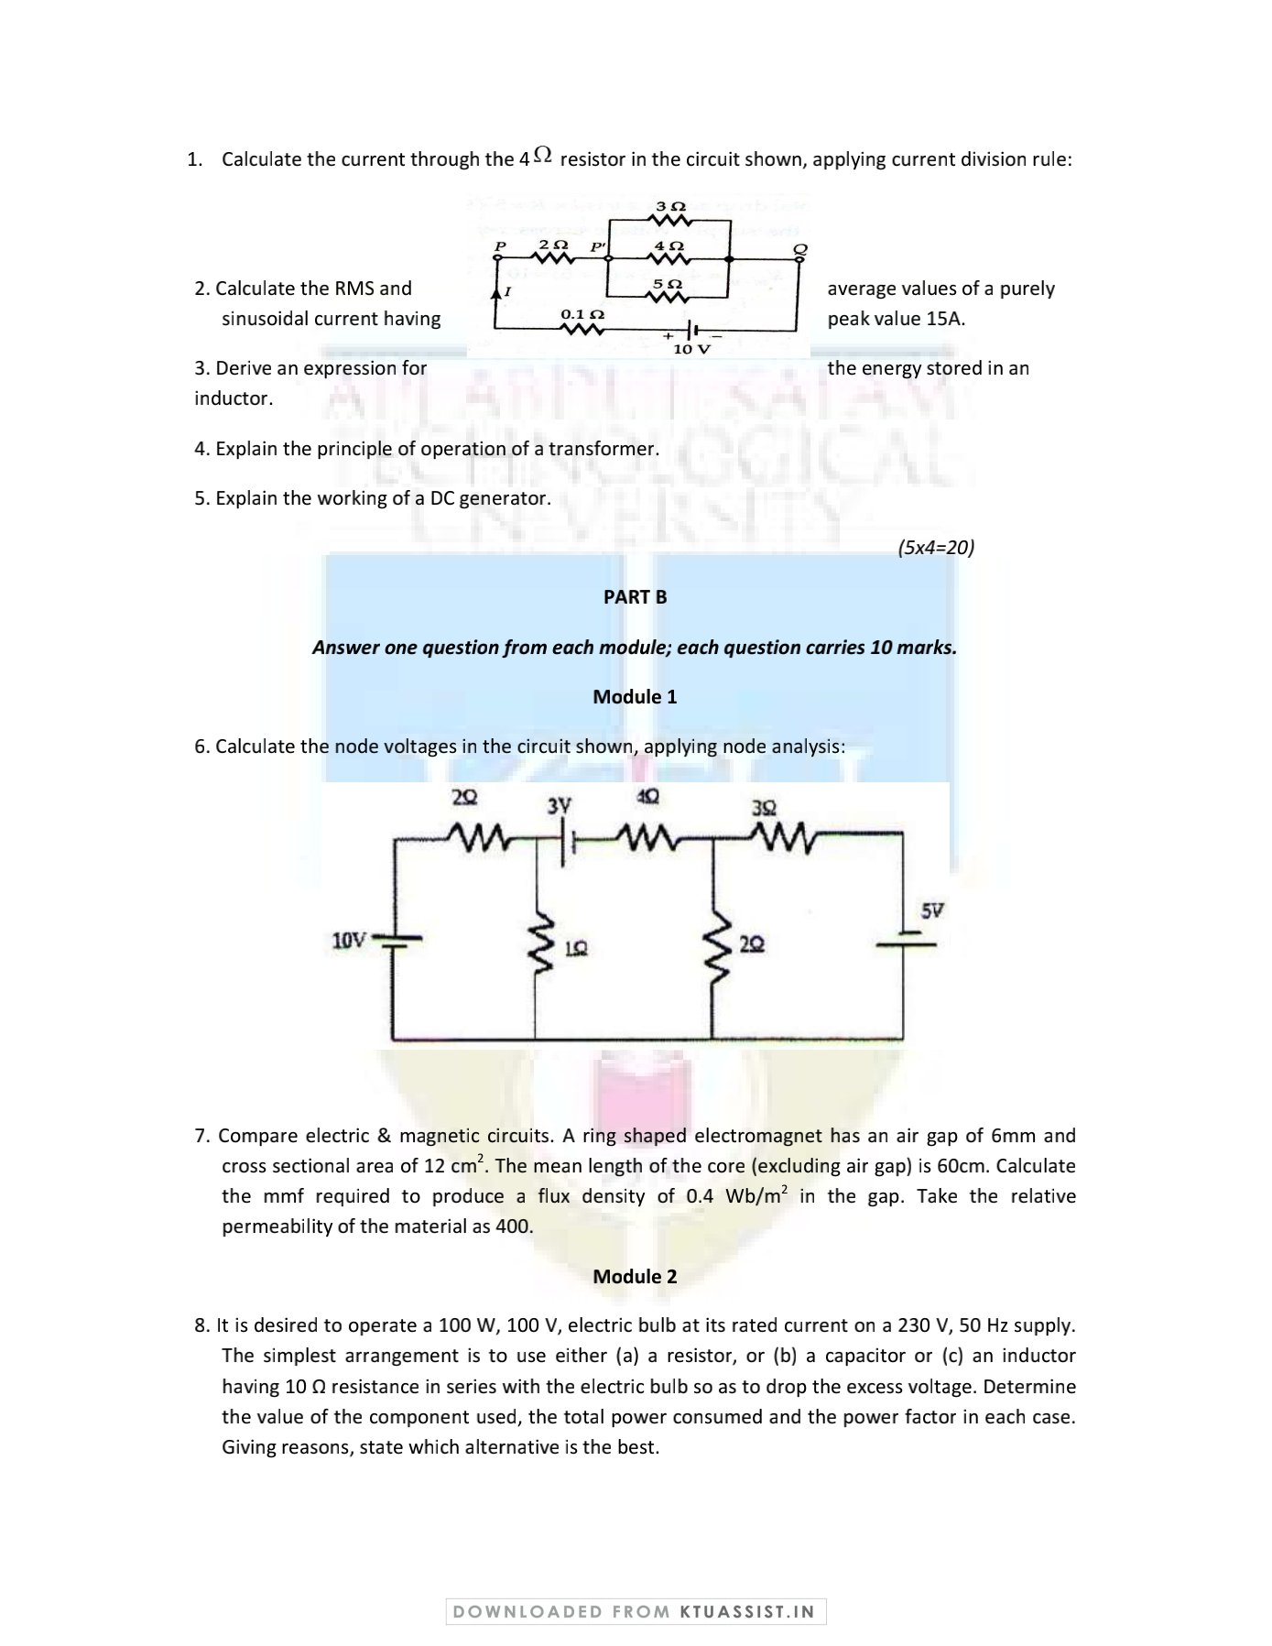

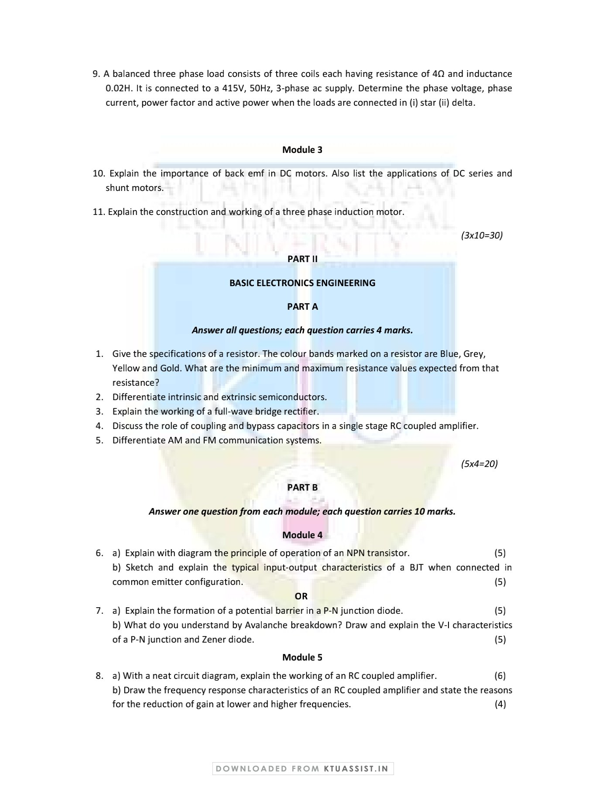

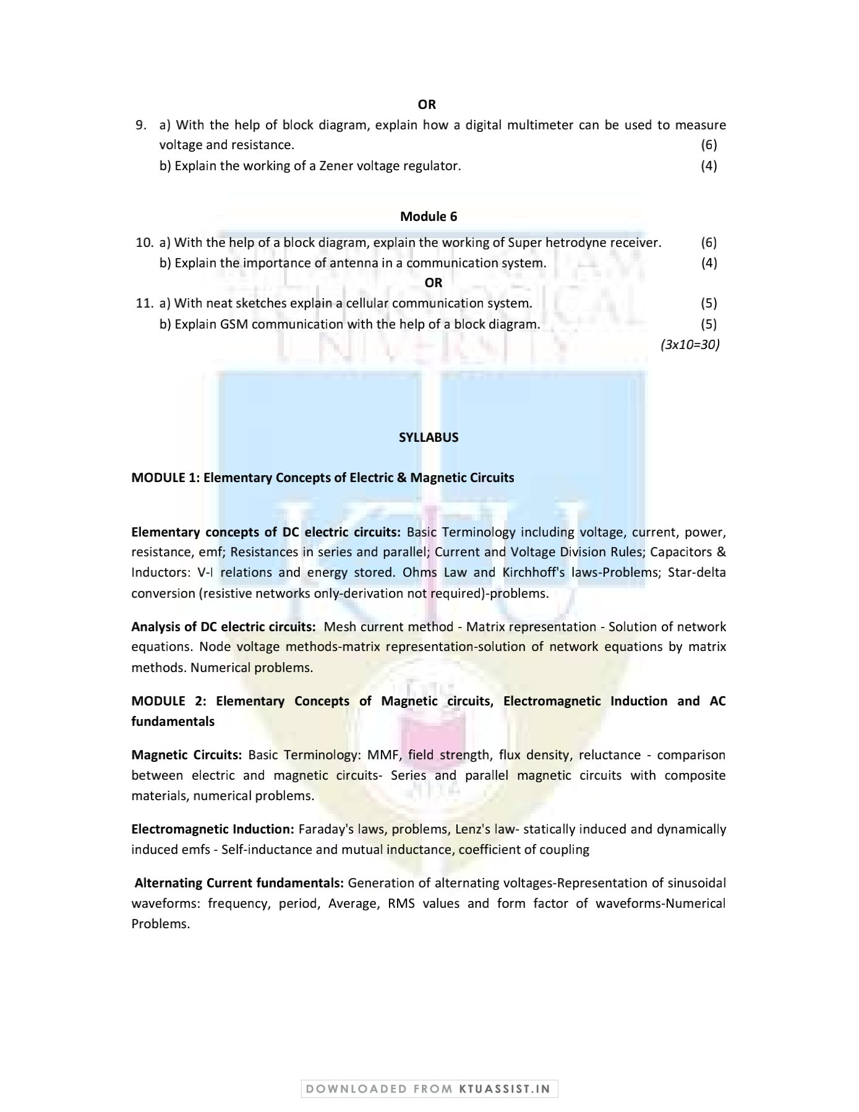

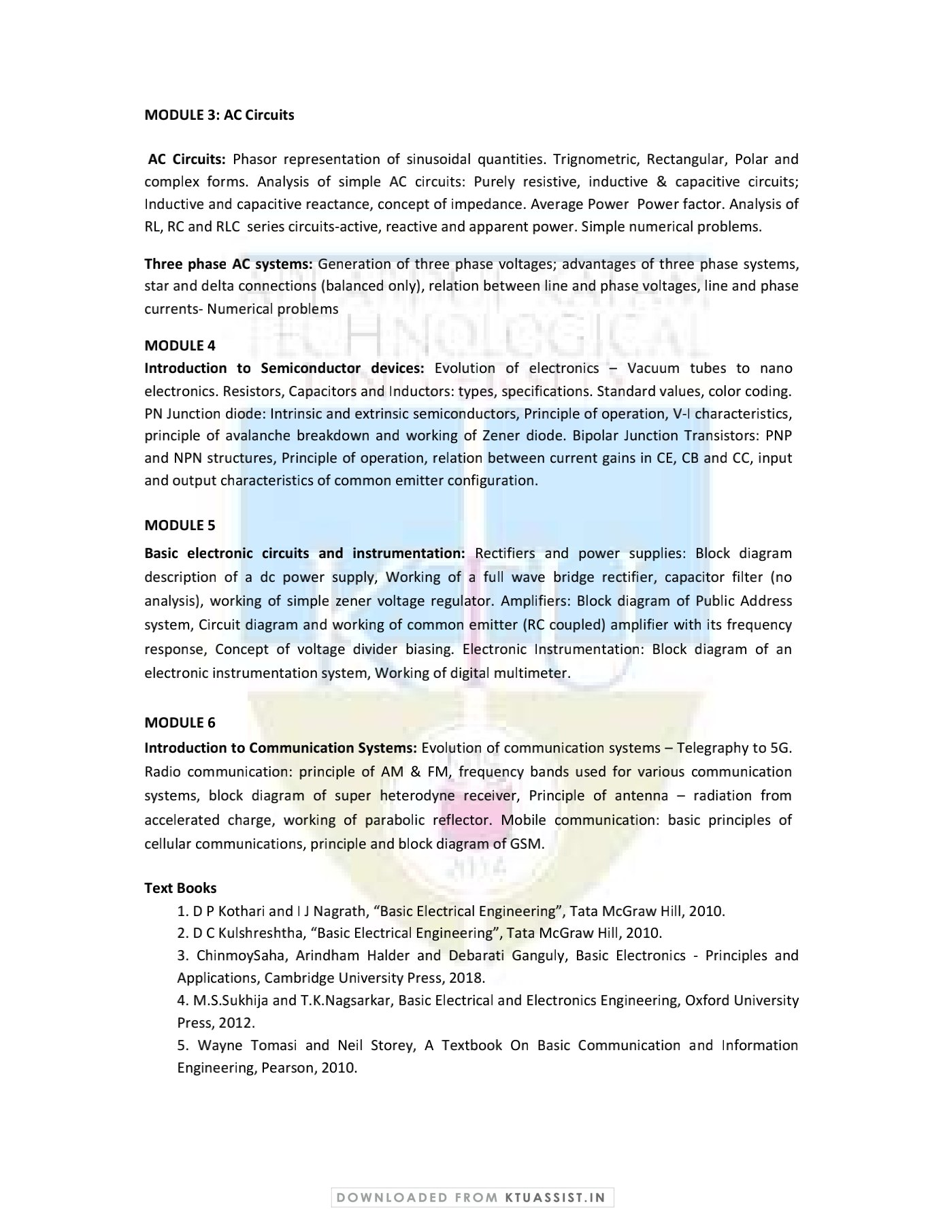

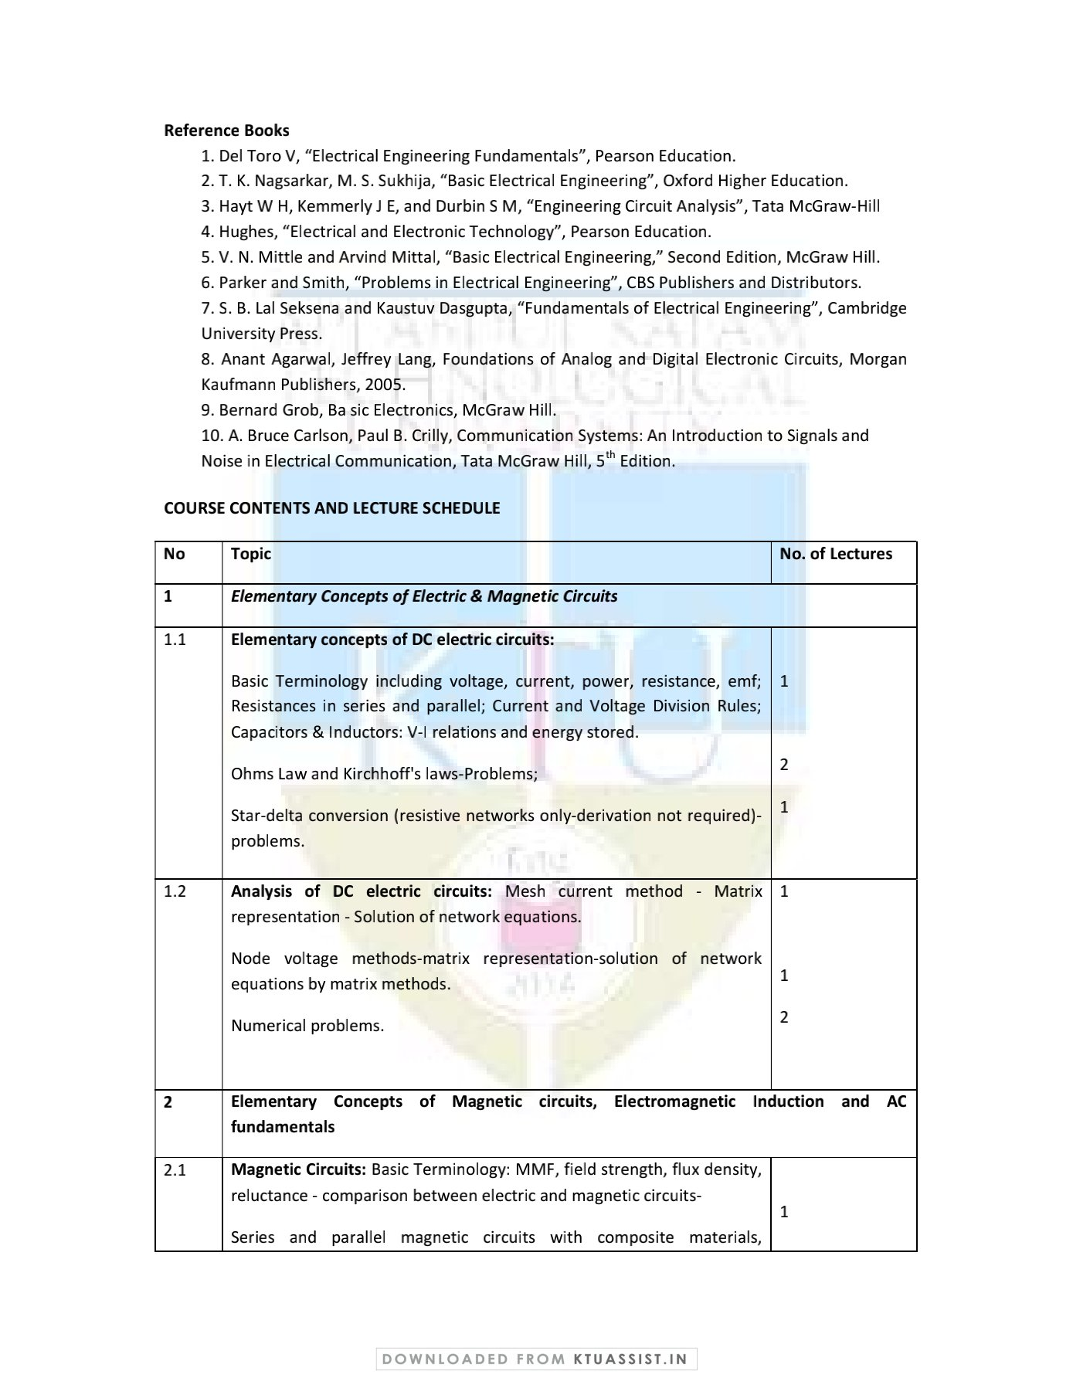



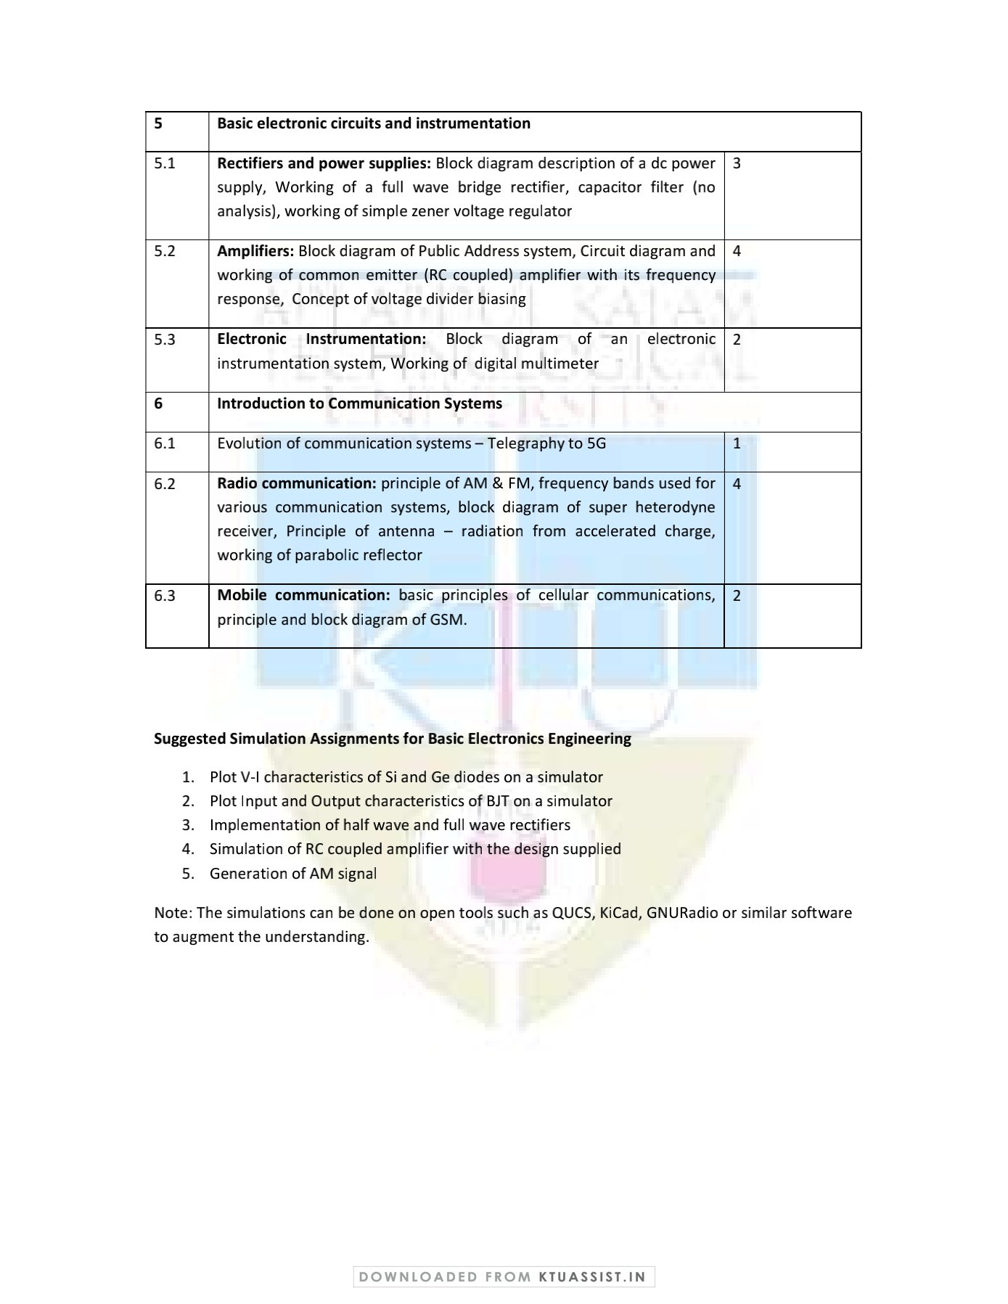

QUESTION BANK

MODULE 4
Q.NO | Questions | CO | KL | Page No
1 | Write down the different applications in the field of electronics | CO4 | K3 | 18
2 | Differentiate between active and passive components | CO4 | K2 | 22
3 | Write a short note on active components with examples | CO4 | K6 | 22
4 | Write a short note on passive components with examples | CO4 | K6 | 22
5 | State the ohm’s law | CO4 | K1 | 22
6 | What is the colour code for a 4.7kΩ resistor with 5% tolerance value? | CO4 | K5 | 30
7 | What is the nominal resistance of a resistor with colour code orange-white-brown? | CO4 | K4 | 30
8 | What is the colour code for a 560kΩ resistor with 10% tolerance value? | CO4 | K5 | 30
9 | What is the colour code for a 22Ω resistor with 20% tolerance value? | CO4 | K5 | 30
10 | Describe the different types of fixed resistors | CO4 | K1 | 24
11 | Describe the different types of variable resistors | CO4 | K1 | 27
12 | How capacitors are classified? | CO4 | K2 | 33
13 | Write a short note on inductor and its classifications. | CO4 | K3 | 40
14 | Describe the working of pn junction diode with I-V characteristics. | CO4 | K1 | 44
15 | Describe the working of zener junction diode with I-V characteristics. | CO4 | K1 | 46
16 | Compare avalanche breakdown and zener breakdown | CO4 | K1 | 49
17 | Explain about the operation of NPN transistor. | CO4 | K2 | 50
18 | Explain about the operation of PNP transistor. | CO4 | K2 | 52
19 | Mention the three regions in which a transistor can operate. | CO4 | K2 | 53
20 | Obtain the relationship for the current gain of CE, CB and CC configurations. | CO4 | K3 | 56
21 | Draw and explain the input output characteristics of CE configuration. | CO4 | K1 | 57

MODULE 5
Q.NO | Questions | CO | KL | Page No
1 | Draw and explain the working of half wave rectifier | CO5 | K2 | 60
2 | Define Ripple factor | CO5 | K1 | 60
3 | Compare and contrast Half wave rectifier, full wave bridge rectifier and full wave centre tapper rectifier | CO5 | K5 | 63
4 | Draw and explain the working of full wave bridge rectifier | CO5 | K1 | 61
5 | Draw and explain the working of full wave centre tapped rectifier | CO5 | K4 | 62
6 | With suitable diagram explain the working of DC power supply | CO5 | K2 | 59
7 | Give a detailed description about the working of zener voltage regulator. | CO5 | K1 | 65
8 | Explain the working of a Zener voltage Regulator | CO5 | K4 | 65
9 | With the help of a block diagram, explain how a digital multimeter can be used to measure voltage and resistance. | CO5 | K5 | 66
10 | With a neat circuit diagram, explain the working of an RC coupled amplifier. | CO5 | K4 | 68
11 | Draw the frequency response characteristics of an RC coupled amplifier and state the reasons for the reduction of gain at lower and higher frequencies. | CO5 | K2 | 70
12 | Explain the concept of voltage divider biasing | CO5 | K1 | 72
13 | Draw and explain the block diagram of an electronic instrumentation system. | CO5 | K1 | 73
14 | Discuss in detail about public addressing system | CO5 | K6 | 66
15 | Draw and explain the working of a dc power supply. | CO5 | K4 | 59

MODULE 6
Q.NO | Questions | CO | KL | Page No
1 | List out the frequency bands used for various communication systems. | CO6 | K1 | 84
2 | Write a short note about the evolution of communication systems | CO6 | K3 | 75
3 | Elaborate in detail about the principle of AM & FM | CO6 | K6 | 77
4 | With neat block diagram, explain super heterodyne receiver. | CO6 | K2 | 85
5 | With neat block diagram explain the stages of GSM | CO6 | K1 | 97
6 | Give a brief description about the principle of antenna. | CO6 | K1 | 88
7 | Explain the principle of GSM. | CO6 | K5 | 97
8 | Differentiate between Amplitude modulation and Frequency modulation. | CO6 | K1 | 77
9 | With neat sketches explain a cellular communication system | CO6 | K3 | 89
10 | Give a detailed description on the evolution of communication systems | CO6 | K4 | 75
11 | Explain the working of parabolic reflector | CO6 | K5 | 89
12 | Discuss the principle in which the radiation from accelerated charge occurs. | CO6 | K2 | 87

APPENDIX 1
CONTENT BEYOND THE SYLLABUS
S:NO; | TOPIC | PAGE NO:
1 | Types of Antenna | 100
2 | Radiation Antenna | 100

MODULE NOTES
MODULE 4

Evolution of electronics
The word 'electronics' is derived from electron mechanics, which means the study of the behavior of an electron under different conditions of externally applied fields. The Institution of Radio Engineers (IRE) has given a standard definition of electronics as "that field of science and engineering, which deals with electron devices and their utilization."
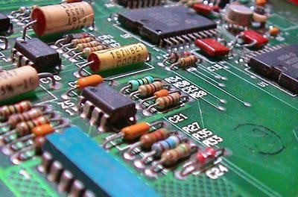
Applications of electronics
Electronics play a major role in almost every sphere of our life. The main applications of electronics are as follows.
Communication and Entertainment In communication,
the main application of electronics was in the field of telegraphy and telephony. This utilizes a pair of wires. However, it is now possible with the help of radio waves to transmit any message from one place to another, thousands of kilometers away, without any wires. With such wireless communication (radio broadcasting), people in any part of the world can know what is happening in other parts. Radio and TV broadcasting provide a means of both communication as well as entertainment. With the help of satellites it has become possible to establish instant communication between places very far apart.
Defense Applications
One of the most important developments during World War II was the RADAR. By using radar it is possible to detect and find the exact location of the enemy aircraft.The antiaircraft guns directed to shoot down the aircraft. The radar and antiaircraft guns can be linked by an automatic control system to make a complete unit.
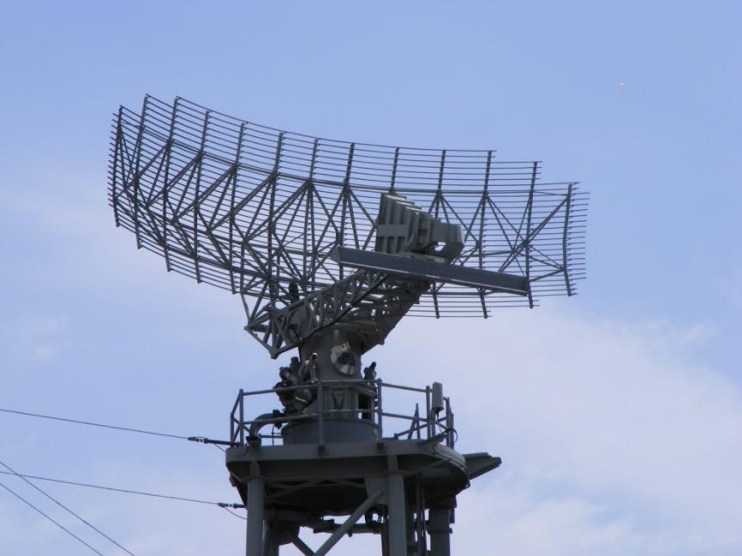
Guided missiles are completely controlled by electronic circuits. In a war, success or defeat for the nation depends on the reliability of its communication system.
Industrial Applications
Use of automatic control systems in industries is increasing day by day. Electronic circuits are used in industrial applications like control of thickness, quality, weight and moisture content of a material. It is also used in automatic dooropeners, lightning systems, power systems and safety devices.
Medical Sciences
Doctors and scientists are constantly finding new uses for electronic systems in the diagnosis and treatment of various diseases. Some of the instruments which have been in use are: Xrays, for taking pictures of internal bone structures and also treatment of some diseases Electrocardiographs (ECG), to find the condition of the heart of a patient. Shortwave diathermy units, for healing sprains and fractures. Oscillographs for studying muscle action.
Instrumentation
Instrumentation plays a very important role in any industry and research organization,for precise measurement of various quantities. e,g. VTVM, CRO, frequency counters, pHmeters,straingauges,etc
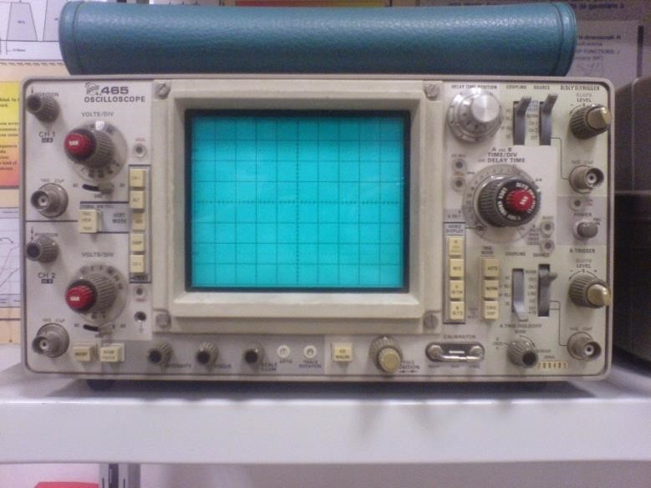
CRO
Integrated circuit

An integrated circuit or monolithic integrated circuit (also referred to as an IC, a chip, or a microchip) is a set of electronic circuits on one small flat piece (or "chip") of semiconductor material that is normally silicon. The integration of large numbers of tiny MOS transistors into a small chip results in circuits that are orders of magnitude smaller, faster, and less expensive than those constructed of discrete electronic components.
Integrated circuits were made practical by technological advancements in metal–oxide– silicon (MOS) semiconductor device fabrication. Since their origins in the 1960s, the size, speed, and capacity of chips have progressed enormously, driven by technical advances that fit more and more MOS transistors on chips of the same size – a modern chip may have many billions of MOS transistors in an area the size of a human fingernail. These advances, roughly following Moore's law, make computer chips of today possess millions of times the capacity and thousands of times the speed of the computer chips of the early 1970s.
In the early days of simple integrated circuits, the technology's large scale limited each chip to only a few transistors, and the low degree of integration meant the design process was relatively simple. Manufacturing yields were also quite low by today's standards. As the technology progressed, millions, then billions of transistors could be placed on one chip, and good designs required thorough planning, giving rise to the field of electronic design automation, or EDA.
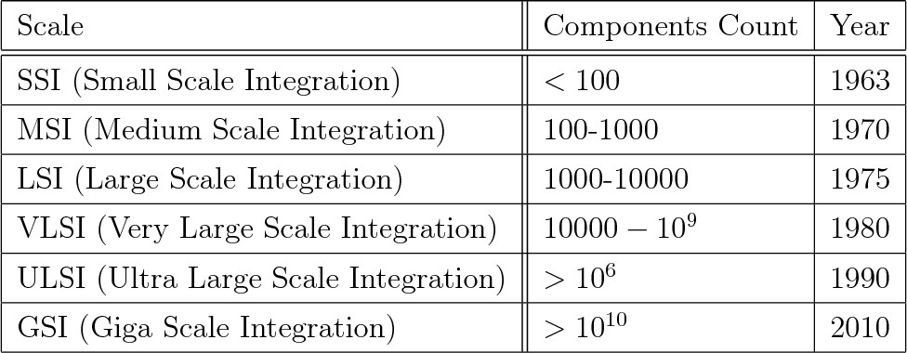

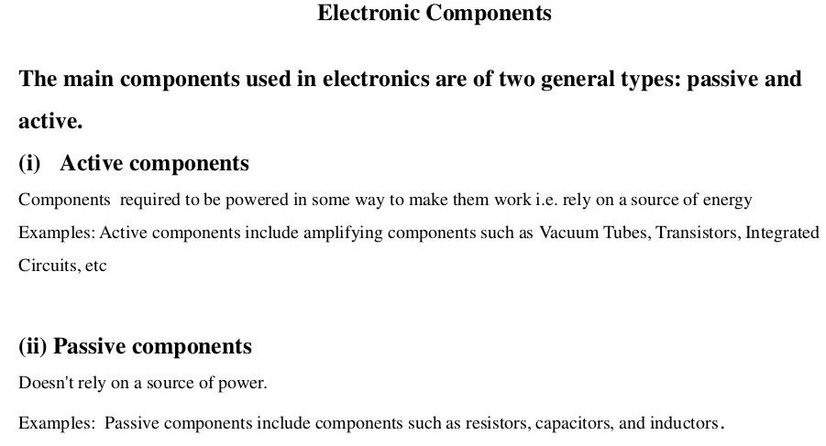
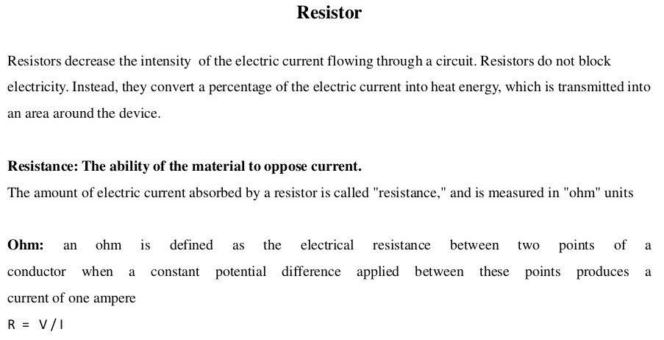
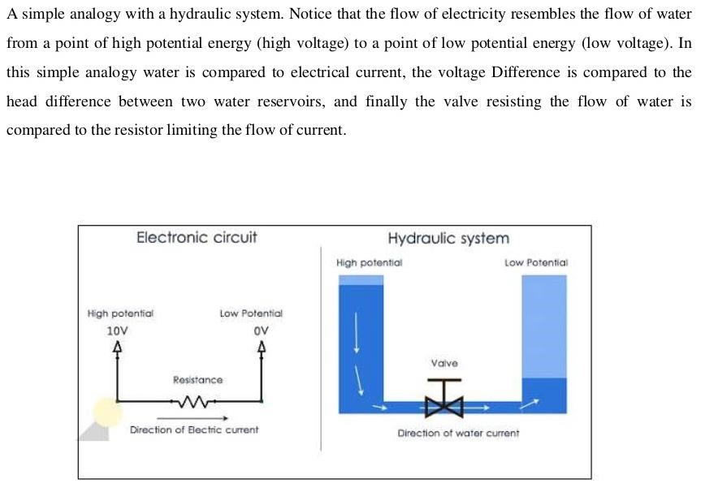

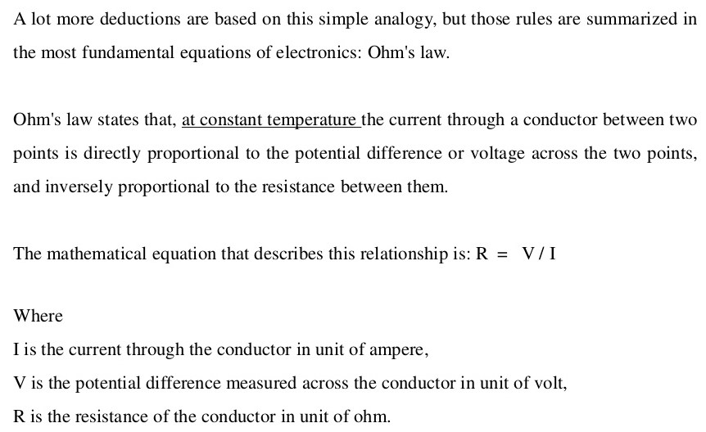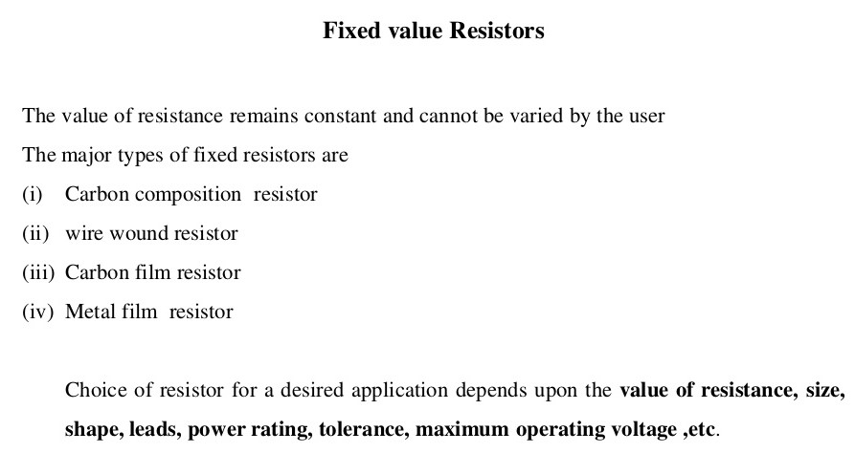

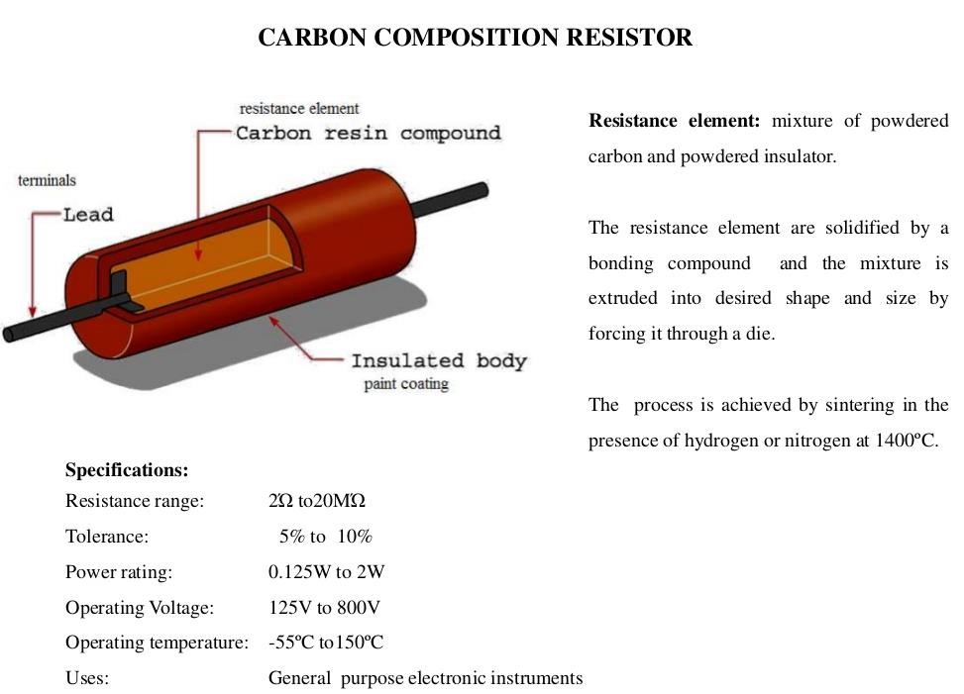
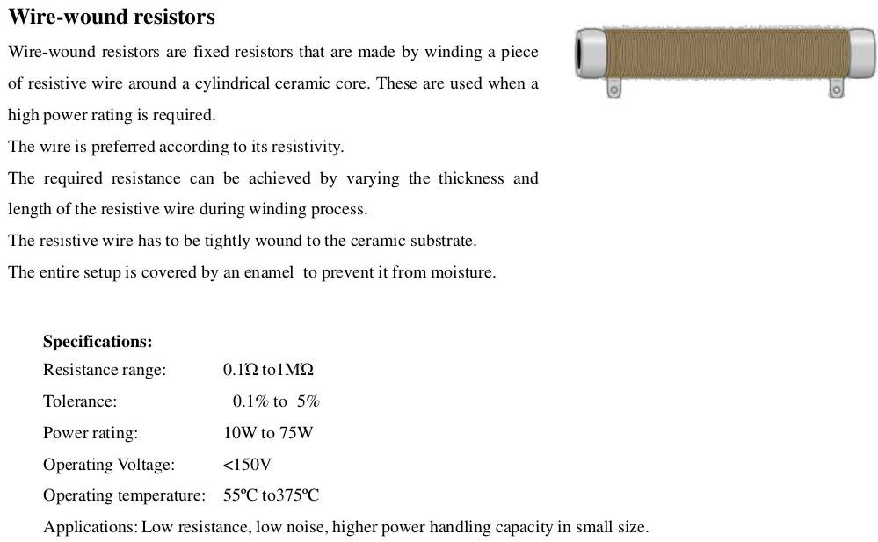
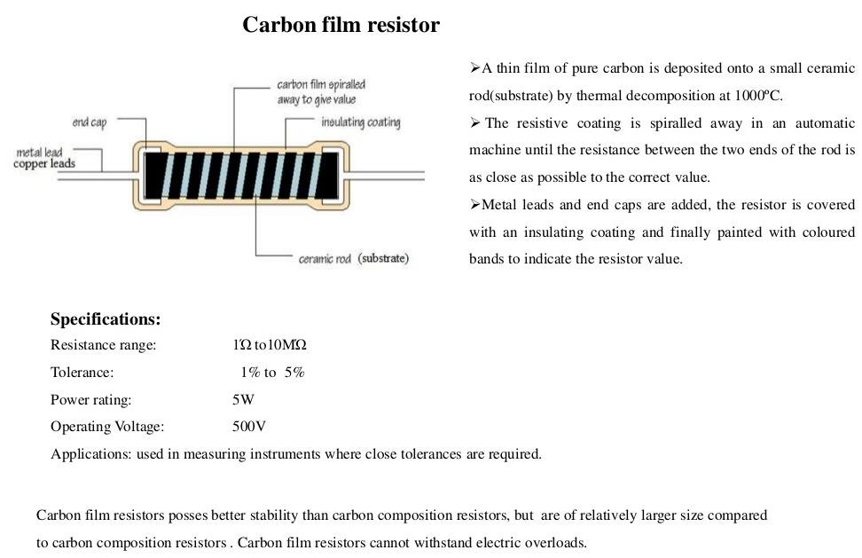
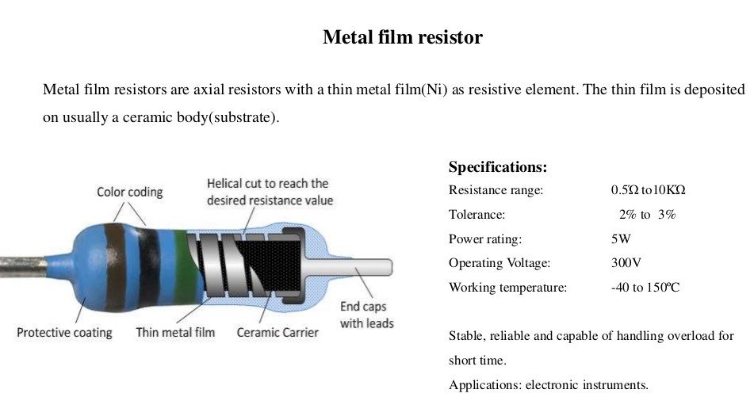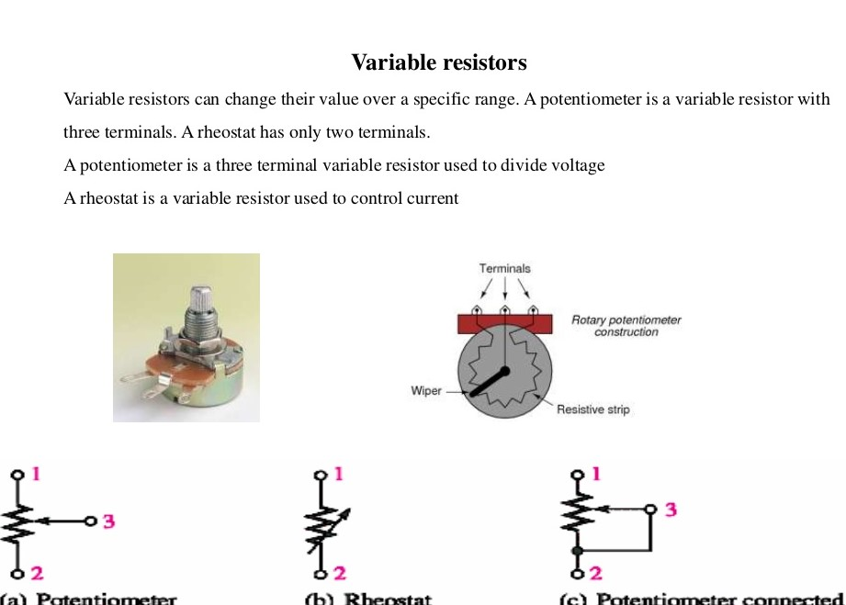

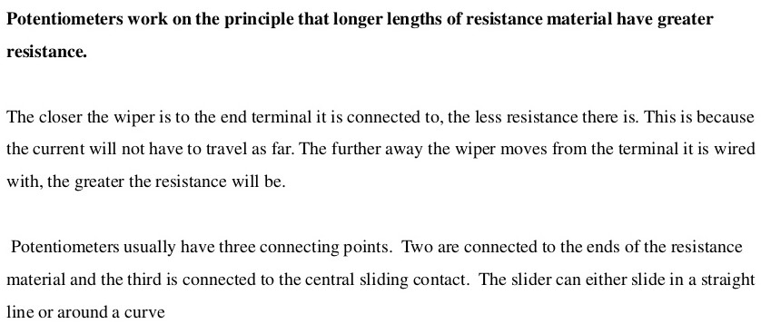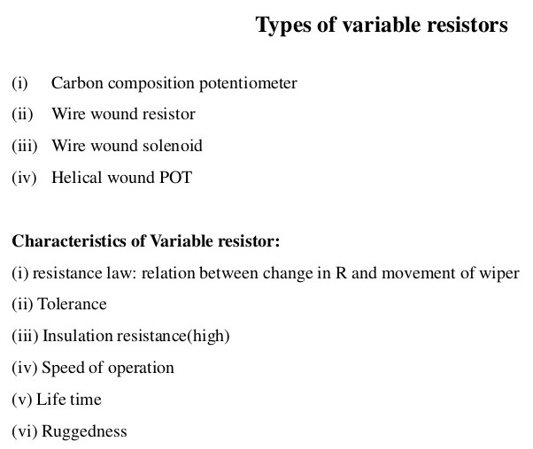

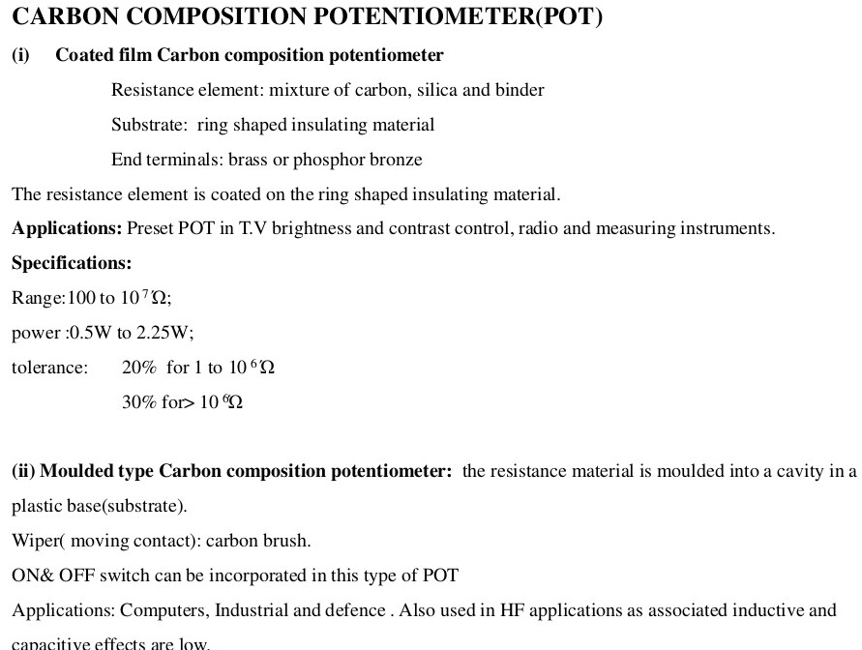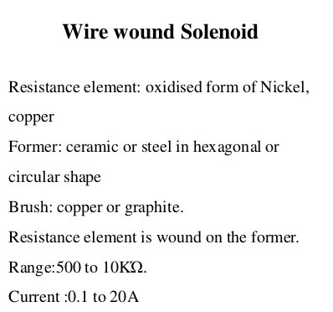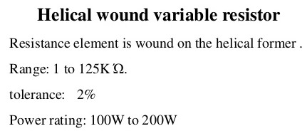

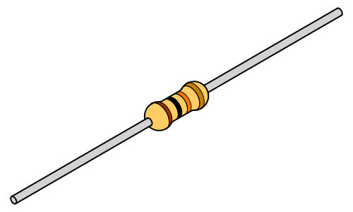
RESISTOR
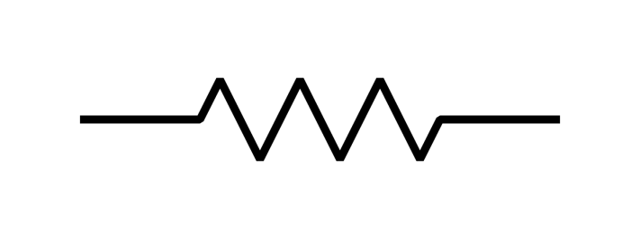
RESITOR SYMBOL
A resistor is a passive electronic component that offers a specific amount of electrical resistance to the flow of current when connected in a circuit. Unit of resistance is ohm (
Symbol Ω ). Ohm is a very small unit. Most practical resistors have resistance in thousands or hundred of thousands of ohm. Therefore resistance is often measured in kilo and megaohms.
Color coding of resistors
Carbon resistors are color coded. Carbon resistors are very small size, it is difficult to write the ohmic values as numbers so color coding is used. Each color has specific numerical values, this help to find the value of the resistor.
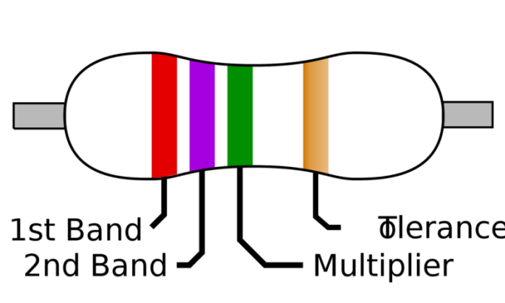
The color bands are read from left to right. The first and second bands represent significant digits respectively of the resistance value. The third band shows the multiplier value. The fourth band gives the tolerance value
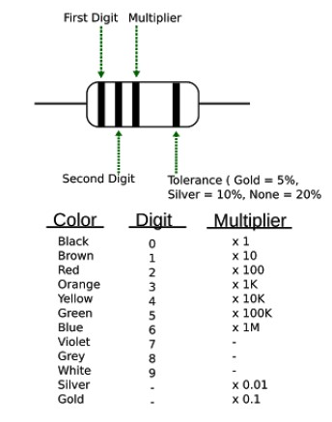

CAPACITORS
Capacitor is a physical device which is capable of storing energy by virtue of a voltage existing across it. Capacitor store energy in electrostatic fields. A capacitor consists of two conducting plates separated by an insulating material, The insulating material is known as dielectric. Capacitance is measured by the ability of capacitor to store charge. Capacitance is measured in farads (F). Practical capacitors are measured in microfarads (µF) and picofarads (pF).
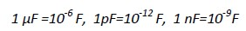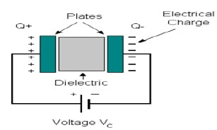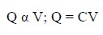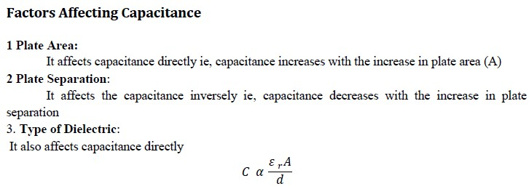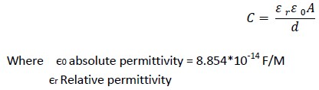

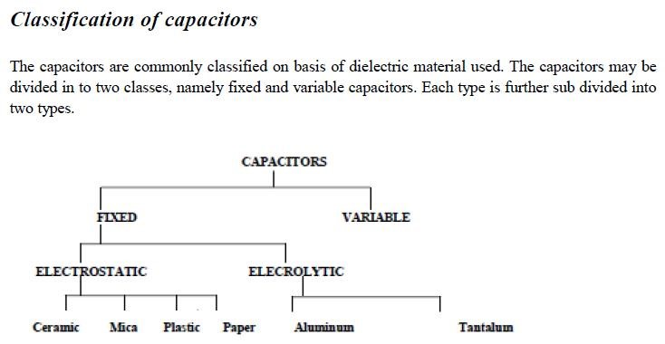

Fixed Capacitors
In fixed capacitors their capacitance value cannot be varied mechanically or by any external means. In fixed capacitors the dielectric is permanently kept in between two fixed plates.
Commonly used fixed capacitors are :

Paper capacitors
Paper capacitors are one of the earliest types of capacitors. They are made by placing paper soaked with mineral oil between two aluminum foils. The entire assembly is rolled up, wire leads are attached to the aluminum foils, and the assembly is enclosed in a cylindrical cardboard case and sealed with wax.
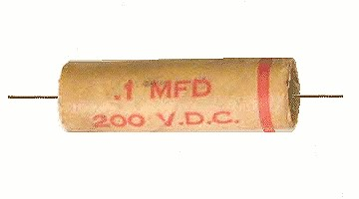
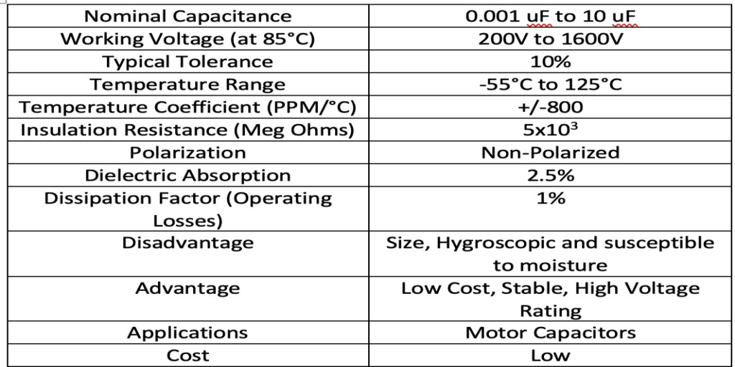

Mica & Metalized Mica capacitors
Mica capacitors use mica sheets as a dielectric and are usually constructed as multi-plate capacitors. A variation of mica capacitors use silver inked mica sheets as a dielectric for better immunity to moisture and ionization. Mica capacitors are known for low tolerance (as low as 1%), low operating losses (dissipation factor of 0.001%), high-quality factor, and stability at high frequency
Capacitance value vary from 1pF to 10,000pF
These capacitors are able to withstand very high voltage about 500V due to high dielectric constant.
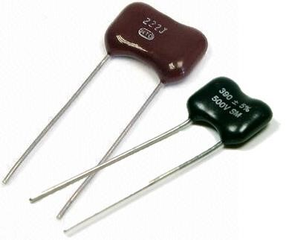

Plastic film capacitors
Film capacitors include many families of capacitors that use different plastics as a dielectric material. They have nearly replaced the paper capacitors in audio, radio circuits, and circuits operating at low to moderate voltages. Some of the commonly used plastics in film capacitors include Polycarbonate, Polyester (PET), Polypropylene
(PP), Polystyrene, Polysulphone, Parylene, Kapton Polyimide, Teflon (PTFE Fluorocarbon), and Metalized Polyester (Metalized Plastic). These capacitors come in a variety of geometries such as oval or round wrap and fill, rectangular epoxy case, round epoxy case, metal hermetically sealed rectangular or round case, and with radial or axial leads.
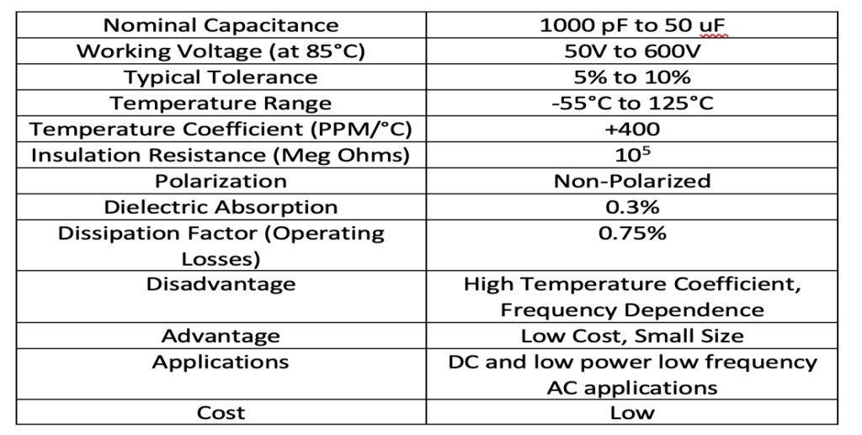

Ceramic capacitors
Ceramic capacitors refer to a wide range of capacitors available as disc capacitors, MLC (Multi-Layer Ceramic) capacitors, and SMD capacitors. The composition of these capacitors varies with the manufacturers. Some of the commonly used materials in the construction of ceramic capacitors include strontium titanate, titanium oxide, barium titanate, etc
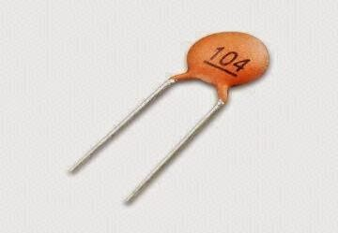
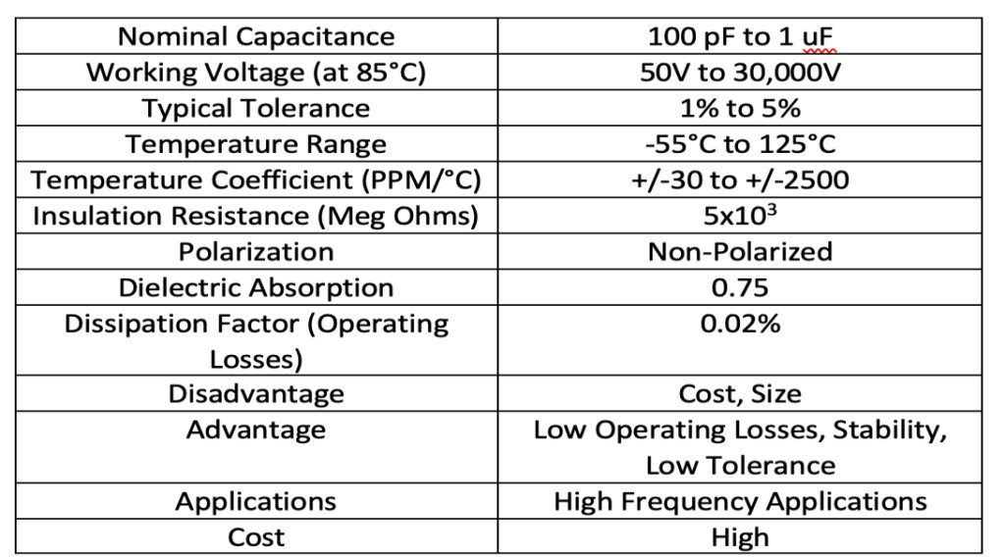

Electrolytic capacitors
Electrolytic Capacitors are polarized capacitors that offer high capacitance per unit volume. Since these capacitors are polarized, they must be hooked up in a circuit with the right polarity. They have one terminal as the anode, which is a metal plate coated with metal oxide; a liquid or solid electrolytic serves as the cathode. When DC current flows through the electrolytic capacitor, the metal plate starts oxidizing due to an electrolytic and a thin insulating metal oxide layer is deposited on it which serves as a dielectric. As the metal oxide layer is extremely thin, it offers very high capacitance per unit volume. Generally, these capacitors are designed to maximize the surface area of the anode.
When connecting these capacitors in reverse polarity, the electrolyte starts emitting gas which expands in the sealed body of the capacitor and may lead to an explosion. These capacitors have significant leakage current, which makes them unsuitable for many applications.
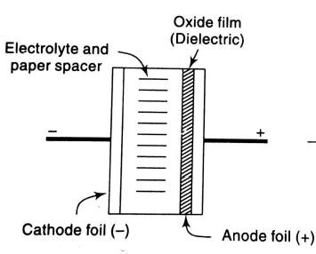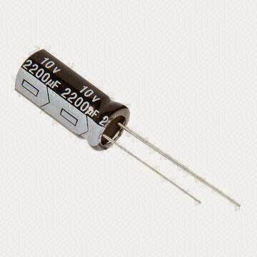

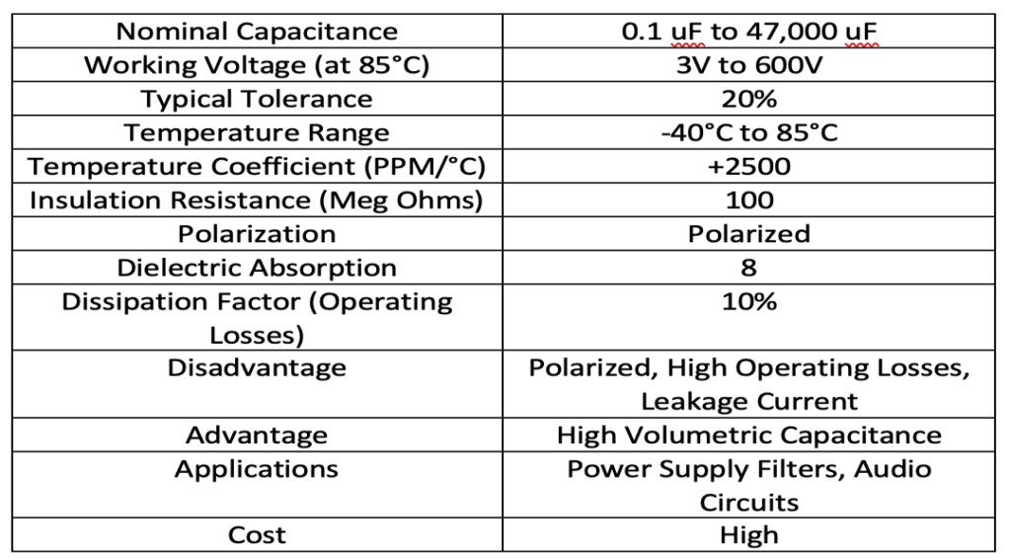

Variable capacitors
The capacitance of the variable capacitors can be varied by changing distance between the conducting plates or by changing the mutual surface area between overlapping plates.
Air Variable (Air-Gap Trimmer) – These variable capacitors have a rotatable set of plates called rotor and a fixed set of plates called stator. The capacitance is varied by rotating a control shaft which varies the distance or surface area between the plates. These capacitors can have a capacitance of a few Picofarad to 1000 Picofarad and voltage rating up to thousands of volts. These non-polarized capacitors were commonly used in RF and audio circuits. Varactor diodes have almost replaced these capacitors.
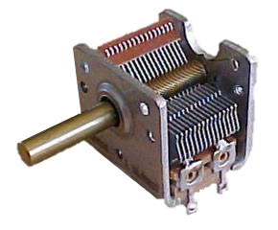

Colour coding of capacitor
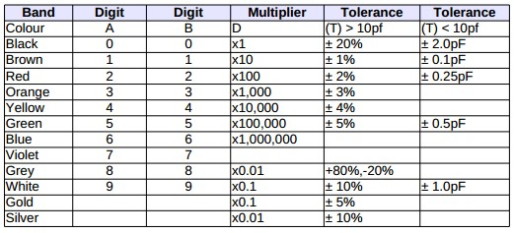

Inductor
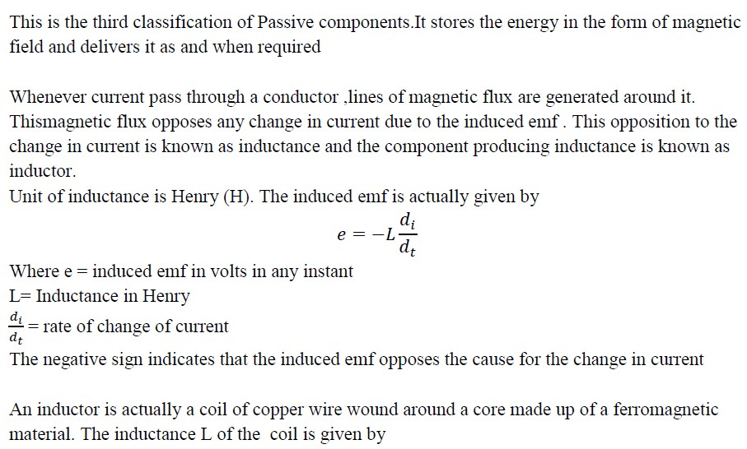

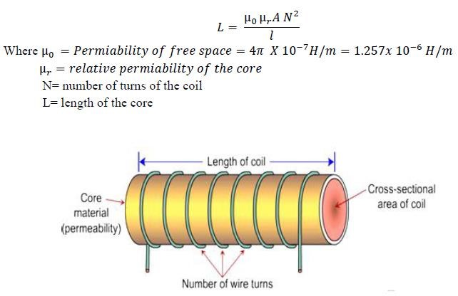
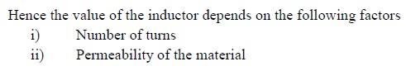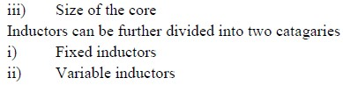

Inductor Types
There are many differnet types of inductor, each with their own properties - understanding the properties of the different types is essential for selecting the right type for a circuit.
Inductors perform a number of different styles of function within a circuit. Some types can be used for filtering and removing spikes on power lines, others are used within high performance filters. Others may be used within oscillators, and there are many other areas where inductors can be used.
As a result of this, there are many different types of inductor that can be obtained. Size, frequency, current, value, and many other factors means that there is a whole host of different types and forms of inductor.
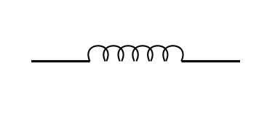
INDUCTOR SYMBOL

Different inductor core types
Like other types of component such as the capacitor, there are very many different types of inductor. However it can be a little more difficult to exactly define the different types of inductor because the variety of inductor applications is so wide.
Although it is possible to define an inductor by its core material, this is not the only way in which they can be categorised. However for the basic definitions, this approach is used.
- Air cored inductor: This type of inductor is normally used for RF applications where the level of inductance required is smaller. The fact that no core is used has several advantages: there is no loss within the core as air is lossless, and this results in a high level of Q, assuming the inductor or coil resistance is low. Against this the number of turns on the coil is larger to gain the same level of inductance and this may result in a physical increase in size.
- Iron cored inductor: Iron cores are normally used for high power and high inductance types of inductor. Some audio coils or chokes may use iron laminate. They are generally not widely used.
- Ferrite cored inductor : Ferrite is one of the most widely used cores for a variety of types of inductor. Ferrite is a metal oxide ceramic based around a mixture of Ferric Oxide Fe2O3 and either manganese-zinc or nickel-zinc oxides which are extruded or pressed into the required shape.
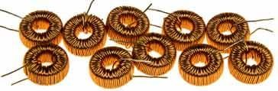
Inductors on a toroidal ferrite former
- Iron power inductor: Another core that can be used in a variety of types of inductor is iron oxide. Like ferrite, this provides a considerable increase in the permeability, thereby enabling much higher inductance coils or inductors to be manufactured in a small space

Different mechanical inductor types and applications
Inductors may also be categorised in terms of their mechanical construction. There are a number of different standard types by which inductors may be categorised:
- Bobbin based inductor: This type of inductor is would on a cylindrical bobbin. They may be designed for printed circuit board mounting, even surface mount of they may be much larger and mounted via some other mechanical means. Some older versions of these inductors may even be in a similar format to normal leaded resistors.
- Toroidal inductor: This form of inductor is wound on a toroid - a circular former. Ferrite is often used as the former as this increases the permeability of the core. The advantage of a toroid is that the toroid enables the magnetic flux to travel in a circle around the toroid and as a result the flux leakage is very low. The disadvantage with a toroidal inductor is that it requires a special winding machine is required to perform the manufacture as the wire has to be passed thought the toroid for each turn required.

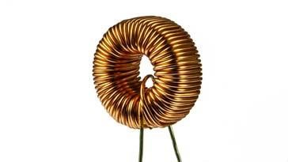
- Multilayer ceramic inductor: This type of inductor is widely used for surface mount technology. The inductor is manufactured within a ferrite or more commonly a magnetic ceramic material. The coil is contained within the body of the ceramic and is presented to the external circuit on end caps in the same way as chip capacitors, etc.
- Film inductor: This form of inductor uses a film of conductor on a base material. The film is then etched or shaped to give the required conductor profile.

PN JUNCTION DIODE
A PN-junction diode is formed when a p-type semiconductor is fused to an n-type semiconductor creating a potential barrier voltage across the diode junction
However, if we were to make electrical connections at the ends of both the N-type and the P-type materials and then connect them to a battery source, an additional energy source now exists to overcome the potential barrier.
The effect of adding this additional energy source results in the free electrons being able to cross the depletion region from one side to the other. The behaviour of the PN junction with regards to the potential barrier’s width produces an asymmetrical conducting two terminal device, better known as the PN Junction Diode.
A PN Junction Diode is one of the simplest semiconductor devices around, and which has the characteristic of passing current in only one direction only. However, unlike a resistor, a diode does not behave linearly with respect to the applied voltage as the diode has an exponential current-voltage ( I-V ) relationship and therefore we can not described its operation by simply using an equation such as Ohm’s law.
If a suitable positive voltage (forward bias) is applied between the two ends of the PN junction, it can supply free electrons and holes with the extra energy they require to cross the junction as the width of the depletion layer around the PN junction is decreased.
By applying a negative voltage (reverse bias) results in the free charges being pulled away from the junction resulting in the depletion layer width being increased. This has the effect of increasing or decreasing the effective resistance of the junction itself allowing or blocking current flow through the diode.
Then the depletion layer widens with an increase in the application of a reverse voltage and narrows with an increase in the application of a forward voltage. This is due to the differences in the electrical properties on the two sides of the PN junction resulting in physical changes taking place. One of the results produces rectification as seen in the PN junction diodes static I-V (current-voltage) characteristics. Rectification is shown by an asymmetrical current flow when the polarity of bias voltage is altered as shown below.
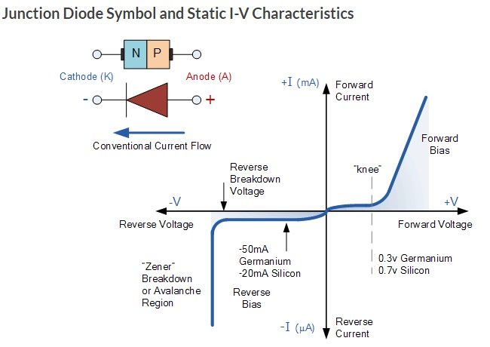
But before we can use the PN junction as a practical device or as a rectifying device we need to firstly bias the junction, ie connect a voltage potential across it. On the voltage axis above, “Reverse Bias” refers to an external voltage potential which increases the potential barrier. An external voltage which decreases the potential barrier is said to act in the “Forward Bias” direction.
There are two operating regions and three possible “biasing” conditions for the standard Junction Diode and these are:
- 1. Zero Bias – No external voltage potential is applied to the PN junction diode.
- 2. Reverse Bias – The voltage potential is connected negative, (-ve) to the P-type material and positive, (+ve) to the N-type material across the diode which has the effect of Increasing the PN junction diode’s width.
- 3. Forward Bias – The voltage potential is connected positive, (+ve) to the P-type material and negative, (-ve) to the N-type material across the diode which has the effect of Decreasing the PN junction diodes width.
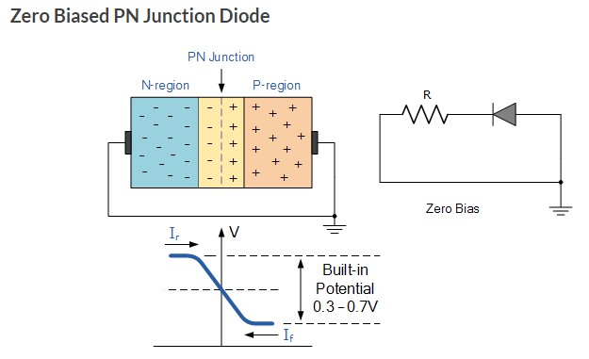
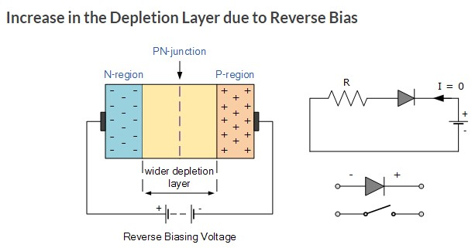
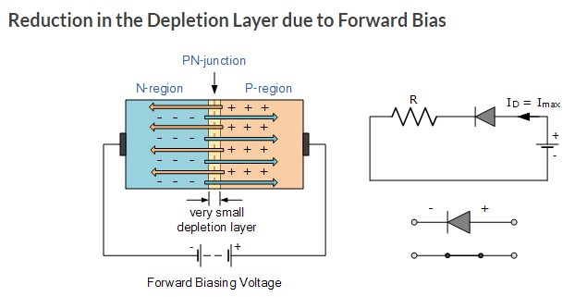
Junction Diode Summary
The PN junction region of a Junction Diode has the following important characteristics:
- Semiconductors contain two types of mobile charge carriers, “Holes” and “Electrons”.
- The holes are positively charged while the electrons negatively charged.
- A semiconductor may be doped with donor impurities such as Antimony (N-type doping), so that it contains mobile charges which are primarily electrons.
- A semiconductor may be doped with acceptor impurities such as Boron (P-type doping), so that it contains mobile charges which are mainly holes.
- The junction region itself has no charge carriers and is known as the depletion region.
- The junction (depletion) region has a physical thickness that varies with the applied voltage.
- When a diode is Zero Biased no external energy source is applied and a natural Potential Barrier is developed across a depletion layer which is approximately 0.5 to 0.7v for silicon diodes and approximately 0.3 of a volt for germanium diodes.
- When a junction diode is Forward Biased the thickness of the depletion region reduces and the diode acts like a short circuit allowing full current to flow.
- When a junction diode is Reverse Biased the thickness of the depletion region increases and the diode acts like an open circuit blocking any current flow, (only a very small leakage current).

ZENER DIODE
- A Zener diode is a type of diode that allows current to flow in the conventional manner - from its anode to its cathode i.e. when the anode is positive with respect to the cathode. When the voltage across the terminals is reversed and the potential reaches the Zener voltage (or "knee"), the junction will breakdown and current will flow in the reverse direction - a desired characteristic. This effect is known as the Zener effect, after Clarence Zener, who first described the phenomenon. Zener diodes are manufactured with a great variety of Zener voltages (Vz) and some are even variable.
- Zener diodes have a highly doped p–n junction. A similar break down is observed in general purpose diodes (which might be quite high), but the voltage and sharpness of the knee is not clearly defined as in Zener diodes. Normal diodes are not designed to operate in the breakdown region and it can cause permanent failure of the device. Zener diodes are manufactured to operate reliably and quite precisely in this region, recovering fully from the junction breakdown and not being harmed in proper use.

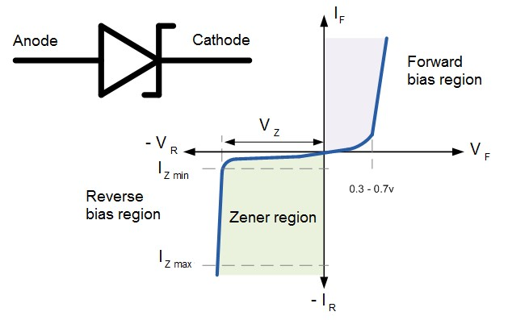

AVALANCHE BREAK DOWN AND ZENER BREAK DOWN
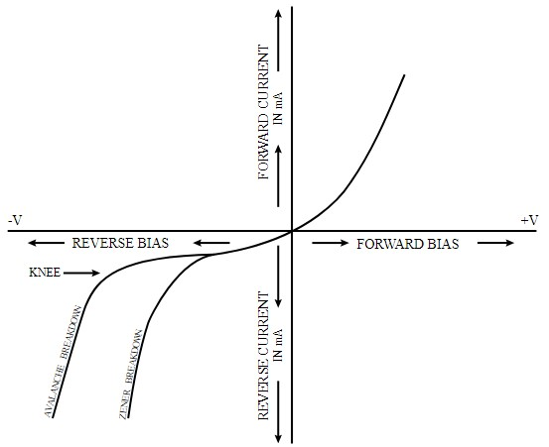
Avalanche breakdown is a phenomenon that can occur in both insulating and semiconducting materials. It is a form of electric current multiplication that can allow very large currents within materials which are otherwise good insulators. It is a type of electron avalanche. The avalanche process occurs when carriers in the transition region are accelerated by the electric field to energies sufficient to create mobile or free electron-hole pairs via collisions with bound electrons.
Materials conduct electricity if they contain mobile charge carriers. There are two types of charge carriers in a semiconductor: free electrons (mobile electrons) and electron holes (mobile holes which are missing electrons from the normally occupied electron states). A normally bound electron (e.g., in a bond) in a reverse-biased diode may break loose due to a thermal fluctuation or excitation, creating a mobile electron-hole pair. If there is a voltage gradient (electric field) in the semiconductor, the electron will move towards the positive voltage while the hole will move towards the negative voltage. Usually, the electron and hole will simply move to opposite ends of the crystal and enter the appropriate electrodes. When the electric field is strong enough, the mobile electron or hole may be accelerated to high enough speeds to knock other bound electrons free, creating more free charge carriers, increasing the current and leading to further "knocking out" processes and creating an avalanche. In this way, large portions of a normally insulating crystal can begin to conduct.
The large voltage drop and possibly large current during breakdown necessarily leads to the generation of heat. Therefore, a diode placed into a reverse blocking power application will usually be destroyed by breakdown if the external circuit allows a large current. In principle, avalanche breakdown only involves the passage of electrons and need not damage to the crystal. Avalanche diodes (commonly encountered as high voltage Zener diodes) are constructed to break down at a uniform voltage and to avoid current crowding during breakdown. These diodes can indefinitely sustain a moderate level of current during breakdown.
The voltage at which the breakdown occurs is called the breakdown voltage. There is a hysteresis effect; once avalanche breakdown has occurred, the material will continue to conduct even if the voltage across it drops below the breakdown voltage. This is different from a Zener diode, which will stop conducting once the reverse voltage drops below the breakdown voltage.
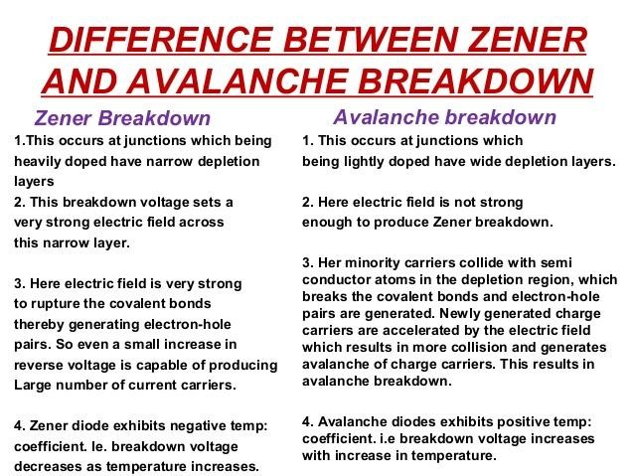

BIPOLAR JUNCTION TRANSISTOR
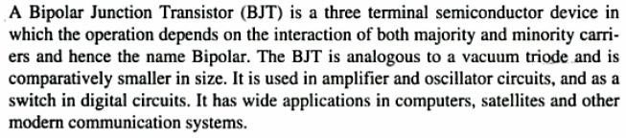

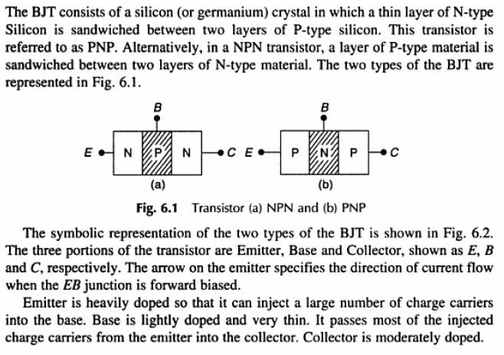

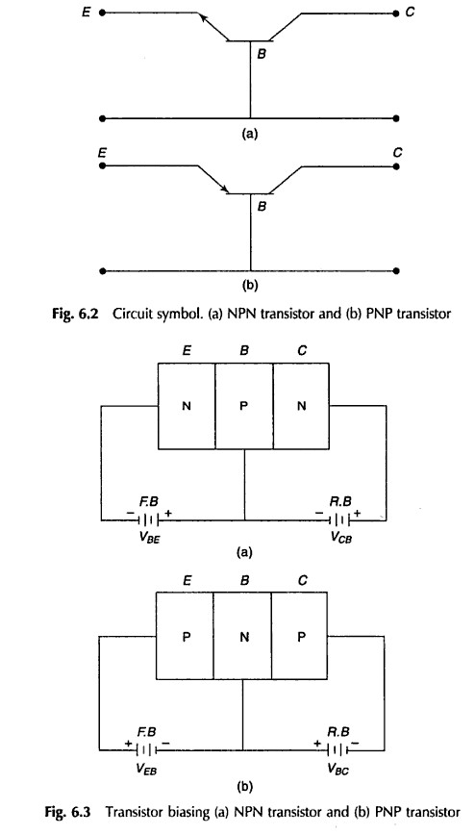
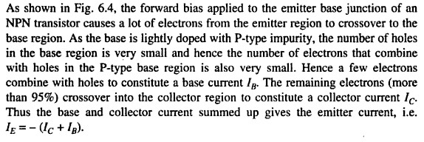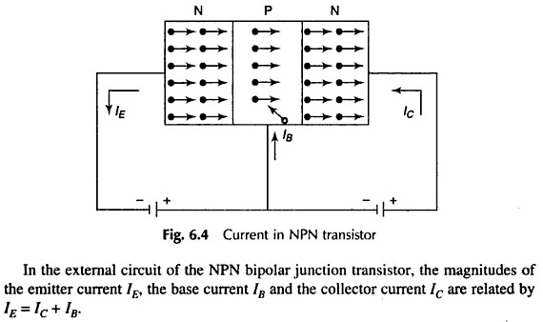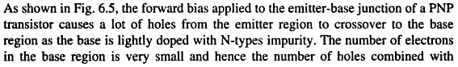

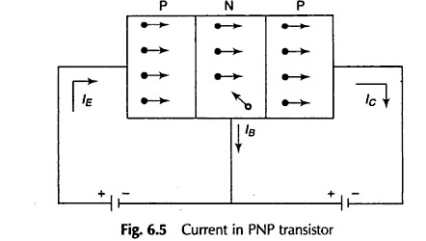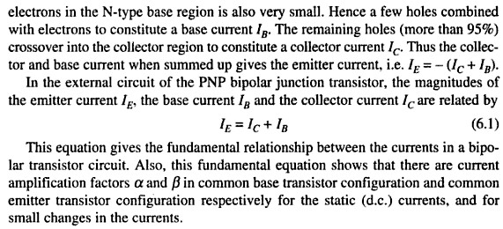

Types of Transistor Configurations
The three different kinds of transistor configurations are
- Common base transistor configuration
- Common emitter transistor configuration
- Common collector transistor configuration

Common Base Transistor Configuration (CB)
The common base transistor configuration gives a low i/p while giving a high o/p impedance. When the voltage of the CB transistor is high, the gain of the current and overall gain of the power is also low compared to the other transistor configurations. The main feature of the B transistor is that the i/p and o/p of the transistor are in phase. The following diagram shows the configuration of CB transistor. In this circuit, the base terminal is mutual to both i/p & o/p circuits.
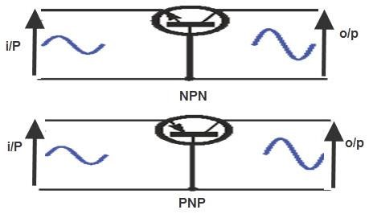
The current gain of the CB circuit is calculated in a method related to that of the CE concept and it is denoted with alpha (α). It is the relationship between collector current and emitter current.The current gain is calculated by using the following formula.
Alpha is the relationship of collector current (output current) to emitter current (input current). Alpha is calculated using the formula:
α =(∆IC )/∆IE

Common Collector Transistor Configuration (CC)
The common collector transistor configuration is also known as the emitter follower because the emitter voltage of this transistor follows the base terminal of the transistor. Offering a high i/p impedance & a low o/p impedance are commonly used as a buffer.The voltage gain of this transistor is unity, the current gain is high and the o/p signals are in phase. The following diagram shows the configuration of CC transistor. The collector terminal is mutual to both i/p and o/p circuits.

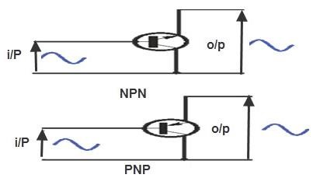
) and it is calculated by using the
The current gain of t
he CC circuit is denoted with (
following formula.
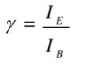

Common Emitter Transistor Configuration (CE)
The common emitter transistor configuration is most widely used configuration. The circuit of CE transistor gives a medium i/p and o/p impedance levels. The gain of the both voltage and current can be defined as a medium, but the o/p is opposite to the i/p that is 1800 change in the phase. This gives a good performance and it is frequently thought of as the most commonly used configurations. The following diagram shows the configuration of CE transistor. In this kind of circuit, the emitter terminal is mutual to both i/p & o/p.
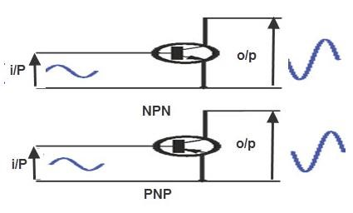
The current gain of the common emitter (CE) circuit is denoted with beta (β).It is the relationship between collector current and base current.The following formula is used to calculate the beta (β). Delta is used to specify a small change
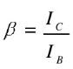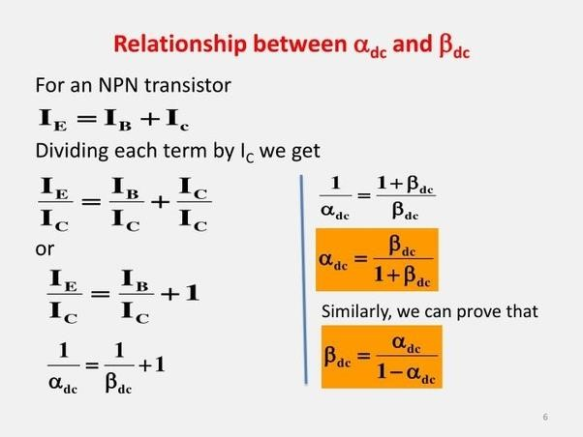

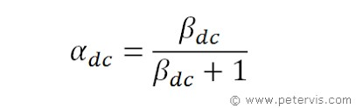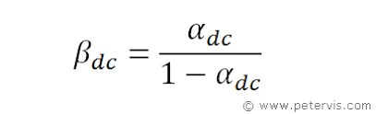

Similarly we can prove,
= β + 1

INPUT AND OUTPUT CHARACTERISTICS OF COMMON EMITTER CONFIGURATION
Transistor Characteristics are the plots which represent the relationships between the current and the voltages of a transistor in a particular configuration. By considering the transistor configuration circuits to be analogous to two-port networks, they can be analyzed using the characteristic-curves which can be of the following types
- Input Characteristics: These describe the changes in input current with the variation in the values of input voltage keeping the output voltage constant.
- Output Characteristics: This is a plot of output current versus output voltage with constant input current.
- Current Transfer Characteristics: This characteristic curve shows the variation of output current in accordance with the input current, keeping output voltage constant.

Common Emitter (CE) Configuration of Transistor
In this configuration, the emitter terminal is common between the input and the output terminals as shown by Figure 9. This configuration offers medium input impedance, medium output impedance, medium current gain and voltage gain.
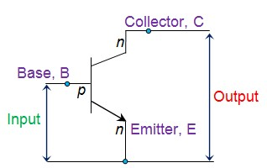

Input Characteristics for CE Configuration of Transistor
Figure 10 shows the input characteristics for the CE configuration of transistor which illustrates the variation in I_{B} in accordance with V_{BE} when V_{CE} is kept constant.
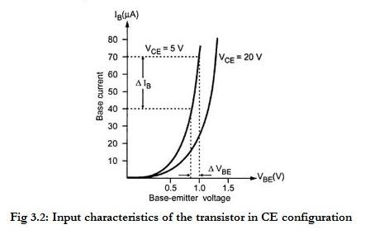
From the graph shown in Figure 10 above, the input resistance of the transistor can be obtained as
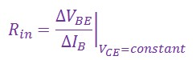

Output Characteristics for CE Configuration of Transistor
The output characteristics of CE configuration (Figure 11) are also referred to as collector characteristics. This plot shows the variation in I_{C} with the changes in V_{CE} when I_{B} is held constant. From the graph shown, the output resistance can be obtained as:
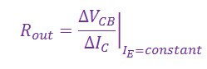
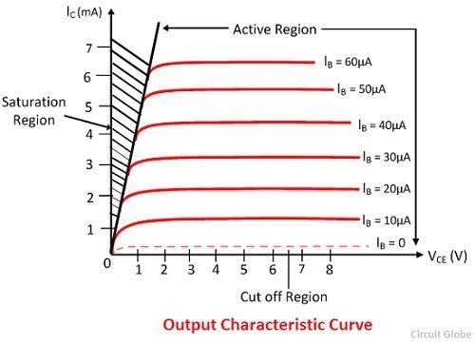

MODULE 5

BLOCK DIAGRAM DESCRIPTION OF A DC POWER SUPPLY

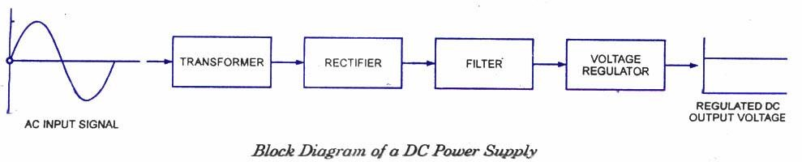
The electrical power is almost exclusively generated, transmitted and distributed in the form of ac because of economical consideration but for operation of most of the electronic devices and circuits, dc supply is required. Dry cells and batteries can be used for this purpose. No doubt, they have the advantages of being portable and ripple free but their voltages are low, they need frequent replacement and are expensive in comparison to conventional dc power supplies.
Now a days, almost all electronic equipment include a circuit that converts ac supply into dc supply. The part of equipment that converts ac into dc is called DC power supply. In general at the input of the power supply there is a power transformer. It is followed by a rectifier (a diode circuit)a smoothing filter and then by a voltage regulator circuit.
From the block diagram, the basic power supply is constituted by four elements viz a transformer, a rectifier, a filter, and a regulator put together. The output of the dc power supply is used to provide a constant dc voltage across the load. Let us briefly outline the function of each of the elements of the dc power supply.
Transformer is used to step-up or step-down (usually to step-down) the-supply voltage as per need of the solid-state electronic devices and circuits to be supplied by the dc power supply. It can provide isolation from the supply line-an important safety consideration. It may also include internal shielding to prevent unwanted electrical noise signal on the power line from getting into the power supply and possibly disturbing the load.
Rectifier is a device which converts the sinusoidal ac voltage into either positive or negative pulsating dc. P-N junction diode, which conducts when forward biased and practically does not conduct when reverse biased, can be used for rectification i.e. for conversion of ac into dc. The rectifier typically needs one, two or four diodes. Rectifiers may be either half-wave rectifiers or full-wave rectifiers (centre-tap or bridge) type.
The output voltage from a rectifier circuit has a pulsating character i.e., it contains unwanted ac components (components of supply frequency f and its harmonics) along with dc component. For most supply purposes, constant direct voltage is required than that furnished by a rectifier. To reduce ac components from the rectifier output voltage a filter circuit is required.
Thus filter is a device which passes dc component to the load and blocks I ac components of the rectifier output. Filter is typically constructed from reactive circuit I elements such as capacitors and/or inductors and resistors.The magnitude of output dc voltage may vary with the variation of either the input ac voltage or the magnitude of load current. So at the output of a rectifier filter combination a voltage regulator is required, to provide an almost constant dc voltage at the output of the regulator. The voltage regulator may be constructed from a Zener diode, and or discrete transistors, and/or integrated circuits (ICs). Its main function is to maintain a constant dc output voltage. However, it also rejects any ac ripple voltage that is not removed by the filter. The regulator may also include protective devices such as short-circuit protection, current limiting, thermal shutdown, or over-voltage protection.

WORKING OF A FULL WAVE BRIDGE RECTIFIER

FULL-WAVE RECTIFICATION
Bridge Rectifier
The dc level obtained from a sinusoidal input can be improved 100% using a process called full-wave rectification. The most familiar network for performing such a function appears in Fig. 2.52 with its four diodes in a bridge configuration. During the period t = 0 to T/2 the polarity of the input is as shown in Fig. 2.53. The resulting polarities across the ideal diodes are also shown in Fig. 2.53 to reveal that D2 and D3 are conducting while D1 and D4 are in the “off” state. The net result is the configuration of Fig. 2.54, with its indicated current and polarity across R. Since the diodes are ideal the load voltage is Vo = Vi, as shown in the same figure

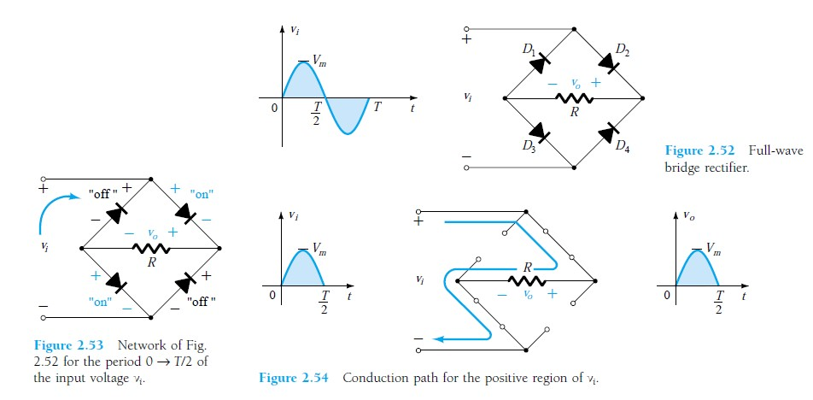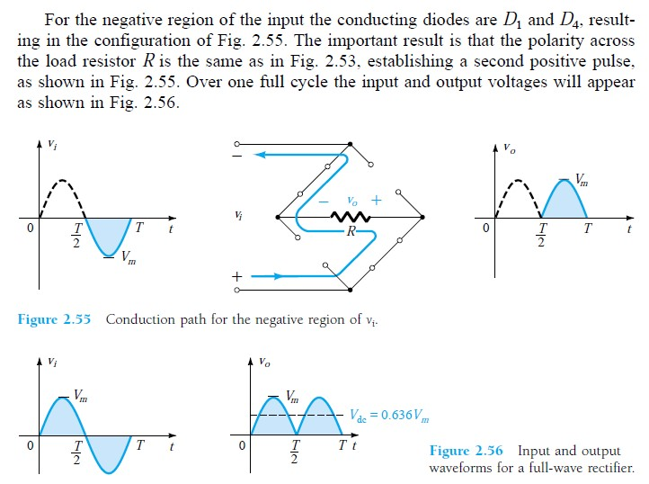

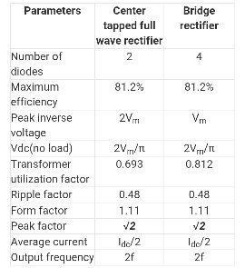

CAPACITOR FILTER
A typical capacitor filter circuit diagram is shown below. The designing of this circuit can be done with a capacitor (C) as well as load resistor (RL). The rectifier’s exciting voltage is given across the terminals of a capacitor. Whenever the voltage of the rectifier enhances then the capacitor will be charged as well as supplies the current to the load.
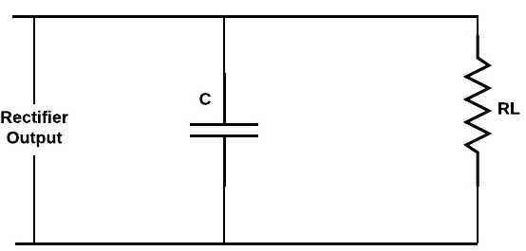
At the last part of the quarter phase, the capacitor will be charged to the highest rectifier voltage value that is denoted with Vm, and then the voltage of the rectifier starts to reduce. As this happens, the capacitor starts discharging through the voltage across it and load. The voltage across the load will reduce little only because the next peak voltage occurs instantaneously to charge the capacitor. This procedure will repeat many times and the output waveform will be seen that very slight ripple is missing in the output. Furthermore, the output voltage is superior because it remains significantly close to the highest value of the output voltage of the rectifier.
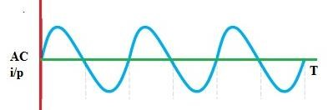
Figure: AC input waveform
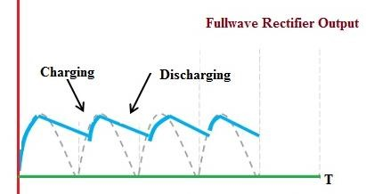

Figure: Output waveform using capacitor filter
A capacitor gives an infinite reactance to DC .For DC, f=0
Xc = 1/ 2пfc = 1/2п x 0 x C = infinite Therefore, a capacitor doesn’t permit DC to flow through it.
The capacitor filter circuit is very famous due to its features like low cost, less weight, small size, & good characteristics. The capacitor filter circuit is applicable for small load currents.

WORKING OF SIMPLE ZENER VOLTAGE REGULATOR
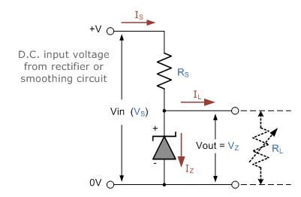
Resistor, R_{S} is connected in series with the zener diode to limit the current flow through the diode with the voltage source, V_{S} being connected across the combination. The stabilised output voltage V_{out} is taken from across the zener diode.
The zener diode is connected with its cathode terminal connected to the positive rail of the DC supply so it is reverse biased and will be operating in its breakdown condition. Resistor R_{S} is selected so to limit the maximum current flowing in the circuit.
With no load connected to the circuit, the load current will be zero, ( I_{L} = 0 ), and all the circuit current passes through the zener diode which in turn dissipates its maximum power. Also a small value of the series resistor R_{S} will result in a greater diode current when the load resistance R_{L} is connected and large as this will increase the power dissipation requirement of the diode so care must be taken when selecting the appropriate value of series resistance so that the zener’s maximum power rating is not exceeded under this no-load or high-impedance condition.
The load is connected in parallel with the zener diode, so the voltage across R_{L} is always the same as the zener voltage, ( V_{R} = V_{Z} ). There is a minimum zener current for which the stabilisation of the voltage is effective and the zener current must stay above this value operating under load within its breakdown region at all times. The upper limit of current is of course dependant upon the power rating of the device. The supply voltage V_{S} must be greater than V_{Z}.
One small problem with zener diode stabiliser circuits is that the diode can sometimes generate electrical noise on top of the DC supply as it tries to stabilise the voltage.
Normally this is not a problem for most applications but the addition of a large value decoupling capacitor across the zener’s output may be required to give additional smoothing.
Then to summarise a little. A zener diode is always operated in its reverse biased condition. As such a simple voltage regulator circuit can be designed using a zener diode to maintain a constant DC output voltage across the load in spite of variations in the input voltage or changes in the load current.
The zener voltage regulator consists of a current limiting resistor R_{S} connected in series with the input voltage V_{S} with the zener diode connected in parallel with the load R_{L} in this reverse biased condition. The stabilised output voltage is always selected to be the same as the breakdown voltage V_{Z} of the diode.

BLOCK DIAGRAM OF PUBLIC ADDRESS SYSTEM

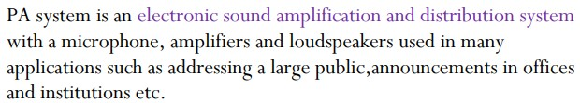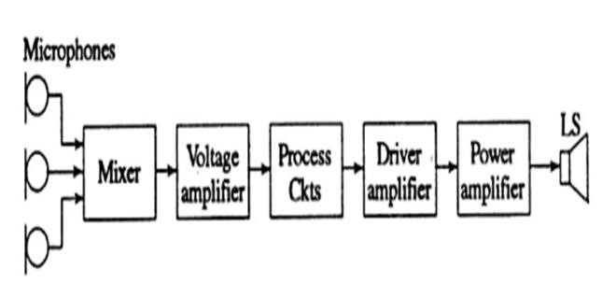

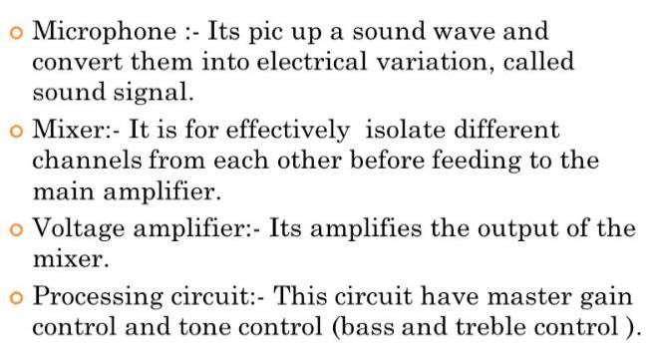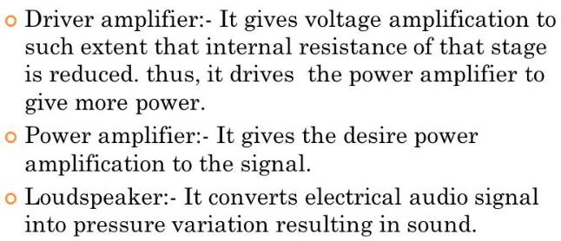

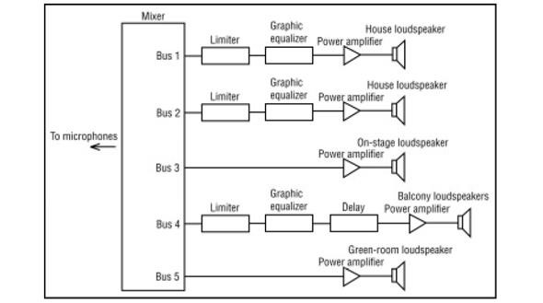
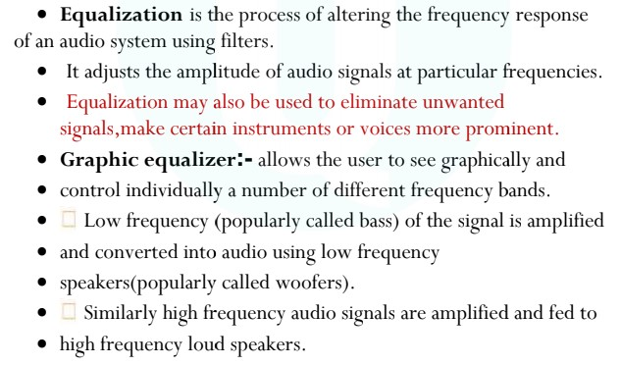

RC Coupled Amplifier

A Resistance Capacitance (RC) Coupled Amplifier is basically a multi-stage amplifier circuit extensively used in electronic circuits. Here the individual stages of the amplifier are connected together using a resistor–capacitor combination due to which it bears its name as RC Coupled.
Figure 1 shows such a two-stage amplifier whose individual stages are nothing but the common emitter amplifiers. Hence the design of individual stages of the RC coupled amplifiers is similar to that in the case of common emitter amplifiers in which the resistors R₁ and R₂ form the biasing network while the emitter resistor RE form the stabilization network. Here the C_{E} is also called bypass capacitor which passes only AC while restricting DC, which causes only DC voltage to drop across R_{E} while the entire AC voltage will be coupled to the next stage.
Further, the coupling capacitor C_{C} also increases the stability of the network as it blocks the DC while offers a low resistance path to the AC signals, thereby preventing the DC bias conditions of one stage affecting the other. In addition, in this circuit, the voltage drop across the collector-emitter terminal is chosen to be 50% of the supply voltage V_{CC} inorder to ensure appropriate biasing point.
In this kind of amplifier, the input signal applied at the base of the transistor in stage 1 (Q₁) is amplified and appears at its collector terminal with a phase-shift of 180º. The AC component of this signal is coupled to the second stage of the RC coupled amplifier through the coupling capacitor C_{C} and thus appears as an input at the base of the second transistor Q₂. This is further amplified and is passed-on as an output of the second stage and is available at the collector terminal of Q₂ after being shift by 180º in its phase. This means that the output of the second stage will be 360º out-of-phase with respect to the input, which inturn indicates that the phase of the input signal and the phase of the output signal obtained at stage II will be identical.
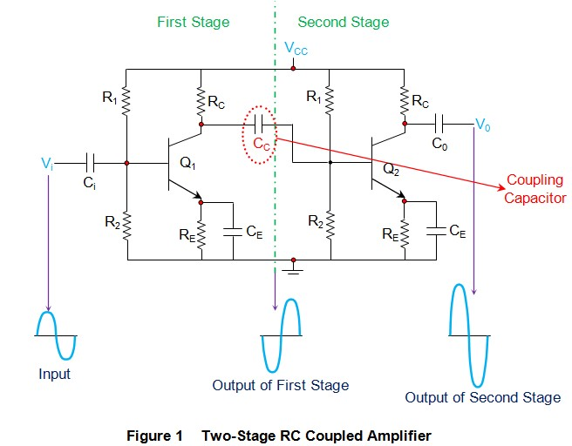
Further it is to be noted that the cascading of individual amplifier stages increases the gain of the overall circuit as the net gain will be the product of the gain offered by the individual stages. However in real scenario, the net gain will be slightly less than this, due to the loading effect. In addition, it is important to note that by following the pattern exhibited by Figure 1, one can cascade any number of common emitter amplifiers but by keeping in mind that when the number of stages are even, the output will be in-phase with the input while if the number of stages are odd, then the output and the input will be out-of-phase.

Frequency Response of RC Coupled Amplifier
Frequency response curve is a graph that indicates the relationship between voltage gain and function of frequency. The frequency response of a RC coupled amplifier is as shown in the following graph.
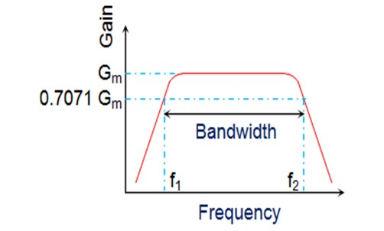
From the above graph, it is understood that the frequency rolls off or decreases for the frequencies below F₁ and for the frequencies above F₂. Whereas the voltage gain for the range of frequencies between F₁ and F₂ is constant.
We know that,
XC=1/2πfc
It means that the capacitive reactance is inversely proportional to the frequency
At Low frequencies (i.e. below 50 Hz)
The capacitive reactance is inversely proportional to the frequency. At low frequencies, the reactance is quite high. The reactance of input capacitor C_{in} and the coupling capacitor C_{C} are so high that only small part of the input signal is allowed. The reactance of the emitter by pass capacitor C_{E} is also very high during low frequencies. Hence it cannot shunt the emitter resistance effectively. With all these factors, the voltage gain rolls off at low frequencies.
At High frequencies (i.e. above 20 KHz)
Again considering the same point, we know that the capacitive reactance is low at high frequencies. So, a capacitor behaves as a short circuit, at high frequencies. As a result of this, the loading effect of the next stage increases, which reduces the voltage gain. Along with this, as the capacitance of emitter diode decreases, it increases the base current of the transistor due to which the current gain (β) reduces. Hence the voltage gain rolls off at high frequencies.
At Mid-frequencies (i.e. 50 Hz to 20 KHz)
The voltage gain of the capacitors is maintained constant in this range of frequencies, as shown in figure. If the frequency increases, the reactance of the capacitor C_{C} decreases which tends to increase the gain. But this lower capacitance reactive increases the loading effect of the next stage by which there is a reduction in gain.
Due to these two factors, the gain is maintained constant.
Advantages of RC Coupled Amplifier
The following are the advantages of RC coupled amplifier.
- The frequency response of RC amplifier provides constant gain over a wide frequency range, hence most suitable for audio applications.
- The circuit is simple and has lower cost because it employs resistors and capacitors which are cheap.
- It becomes more compact with the upgrading technology.
Disadvantages of RC Coupled Amplifier
The following are the disadvantages of RC coupled amplifier.
- The voltage and power gain are low because of the effective load resistance.
- They become noisy with age.
- Due to poor impedance matching, power transfer will be low.
Applications of RC Coupled Amplifier
The following are the applications of RC coupled amplifier.
- They have excellent audio fidelity over a wide range of frequency.
- Widely used as Voltage amplifiers
- Due to poor impedance matching, RC coupling is rarely used in the final stages.

CONCEPT OF VOLTAGE DIVIDER BIASING
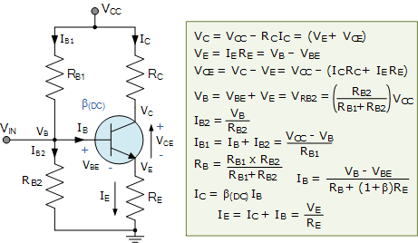

Here the common emitter transistor configuration is biased using a voltage divider network to increase stability. The name of this biasing configuration comes from the fact that the two resistors R_{B1} and R_{B2} form a voltage or potential divider network across the supply with their center point junction connected the transistors base terminal as shown.
This voltage divider biasing configuration is the most widely used transistor biasing method. The emitter diode of the transistor is forward biased by the voltage value developed across resistor R_{B2}. Also, voltage divider network biasing makes the transistor circuit independent of changes in beta as the biasing voltages set at the transistors base, emitter, and collector terminals are not dependant on external circuit values.
To calculate the voltage developed across resistor R_{B2} and therefore the voltage applied to the base terminal we simply use the voltage divider formula for resistors in series.
Generally the voltage drop across resistor R_{B2} is much less than for resistor R_{B1}. Clearly the transistors base voltage V_{B} with respect to ground, will be equal to the voltage across R_{B2}.
The amount of biasing current flowing through resistor R_{B2} is generally set to 10 times the value of the required base current I_{B} so that it is sufficiently high enough to have no effect on the voltage divider current or changes in Beta.
The goal of Transistor Biasing is to establish a known quiescent operating point, or Qpoint for the bipolar transistor to work efficiently and produce an undistorted output signal. Correct DC biasing of the transistor also establishes its initial AC operating region with practical biasing circuits using either a two or four-resistor bias network.
In bipolar transistor circuits, the Q-point is represented by ( V_{CE}, I_{C} ) for the NPN transistors or ( V_{EC}, I_{C} ) for PNP transistors. The stability of the base bias network and therefore the Q-point is generally assessed by considering the collector current as a function of both Beta (β) and temperature.
Here we have looked briefly at five different configurations for “biasing a transistor” using resistive networks. But we can also bias a transistor using either silicon diodes, zener diodes or active networks all connected to the transistors base terminal. We could also correctly bias the transistor from a dual voltage power supply if so wished.

BLOCK DIAGRAM OF INSTRUMENTATION SYSTEM

It is branch of engineering which deals with various types of instrument to record, monitor, indicate and control various physical parameters such as pressure, temperature, etc.
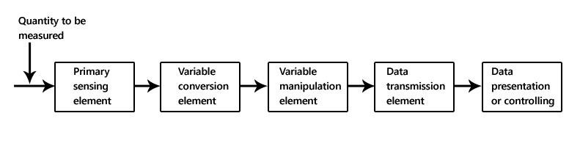
The block diagram shown above is of basic instrumentation system. It consist of primary sensing element, variable manipulation element, data transmission element and data presentation element.

Primary sensing element
The primary sensing element is also known as sensor. Basically transducers are used as a primary sensing element. Here, the physical quantity (such as temperature, pressure etc.) are sensed and then converted into analogues signal.

Variable conversion element
It converts the output of primary sensing element into suitable form without changing information. Basically these are secondary transducers.

Variable manipulation element
The output of transducer may be electrical signal i.e. voltage, current or other electrical parameter. Here, manipulation means change in numerical value of signal. This element is used to convert the signal into suitable range.

Data transmission element
Sometimes it is not possible to give direct read out of the quality at a particular place (Example – Measurement of temperature in the furnace). In such a case, the data should transfer from one place to another place through channel which is known as data transmission element. Typically transmission path are pneumatic pipe, electrical cable and radio links. When radio link is used, the electronic instrumentation system is called as telemetry system.

Data presentation or controlling element
Finally the output is recorded or given to the controller to perform action. It performs different functions like indicating, recording or controlling.

MODULE 6

EVOLUTION OF COMMUNICATION SYSTEMS
Just a few generations ago, our ancestors were dependent on what is now considered primitive communications technology. But it’s all relative. Wired telegraphy that crisscrossed the United States was a major breakthrough in innovation.
Wireless telegraphy in the form of radio made it possible to carry on a conversation without the use of cables. And improvements in radio communications through the years have only expanded the range of service capabilities. Fifth-generation mobile telephony, known simply as 5G, is the latest invention to thrill and amaze the user.
A more recent telecommunications implementation was the use of semaphore by the French. In the 1700s, they built semaphore towers across the country, each at a distance of a few miles but still within sight. Using mechanically controlled flags, a French communications technician could pass messages along to the next tower. Using this method, a message could be transmitted across the country in short order.
These are just a couple of examples of wireless telecommunications (we left out carrier pigeon) that preceded the digital age. It was Guglielmo Marconi who pioneered the use of long-distance radio communication that forms the basis for all our current mobile telephony. At the heart of it all is the electromagnetic spectrum, which includes radio waves with frequencies ranging from 30 Hz to 300 GHz.
Long before mobile telephony was born, various technologies that it would employ were already in use. Push-to-talk (PTT) systems were being used by police and fire personnel. Powerful radio towers streamed news and entertainment across vast distances. AT&T offered a Mobile Telephone Service (MTS) as far back as 1949, and later introduced its Improved Mobile Telephone Service (IMTS) in 1965. Some people have given the name 0G to these mobile network predecessors.
The birth of 1G was a little more obvious. Nippon Telegraph and Telephone (NTT) in Japan rolled out the first generation (1G) of mobile telephony in 1979. Systems from other carriers were quickly to follow. There was an implementation of 1G by Nordic Mobile Telephone in 1981, standards such as Advance Mobile Phone System (AMPS) by Bell Labs in 1982 and C450 in Germany were propagated worldwide.
Second-generation (2G) was started in Finland in 1991. It was based on the GSM standard, and included the introduction of text messaging known as short message service (SMS), as well as other services. Later develops of 2g included general packet radio service (GPRS) and Enhanced Data Rates for GSM Evolution (EDGE).
With the advent of 3G, things started to get interesting. The internet boom of the late 1990s created a demand for users to go online with their mobile phones. The 3rd Generation Partnership Project (3GPP) was formed in 1998 to develop protocols and standards for 3G. It was a group effort by organizations from around the world. The result was the introduction of robust technologies, such as Wideband Code Division Multiple Access (WCDMA) and High Speed Packet Access (HSPA), that made web access at high speeds and capacities possible.
4G, known as Long-term Evolution (LTE), was a whole restructuring of mobile telephony. It was a new way of doing mobile. In fact, they gave the name Systems Architecture Evolution (SAE) to its core network. The Evolved Packet Core (EPC) includes the mobile management entity (MME), the serving gateway (SGW), the PDN gateway (PGW), and the home subscriber server (HSS). On the radio side, the eNodeB takes signals received through the air interface from mobile handsets and transmits them through network interfaces to the core network. LTE took wireless telephony to a whole new level of sophistication.
And now 5G is upon us. Verizon has already started to roll out its 5G Home and its 5G Mobile. Other carriers are hot on their heels. Like 4G, 5G promises to be a whole new rethink of wireless. The final publication of standards is slated for next year as part of the IMT-2020 Vision created by the ITU-T and 3GPP. But it won’t be entirely new. 5G will borrow and build upon technologies from previous generations.
5G is the fifth generation wireless technology for digital cellular networks that began wide deployment in 2019. As with previous standards, the covered areas are divided into regions called "cells", serviced by individual antennas. Virtually every major telecommunication service provider in the developed world is deploying antennas or intends to deploy them soon. The frequency spectrum of 5G is divided into millimeter waves, mid-band and low-band. Low-band uses a similar frequency range as the predecessor, 4G.

RADIO COMMUNICATION:
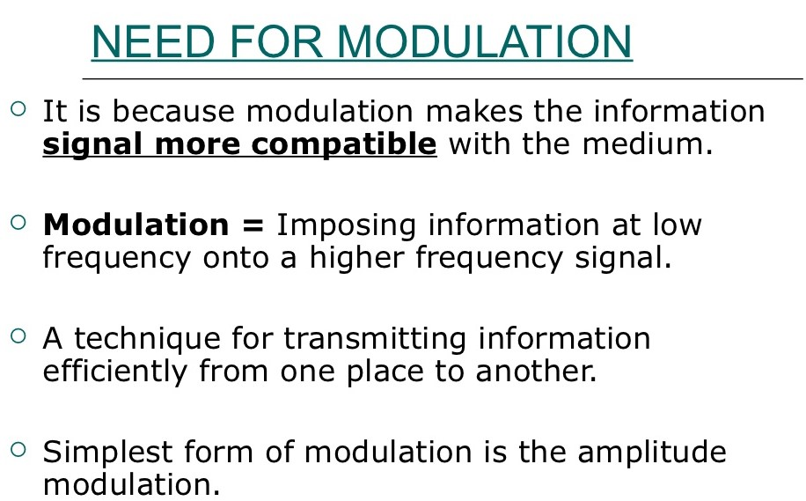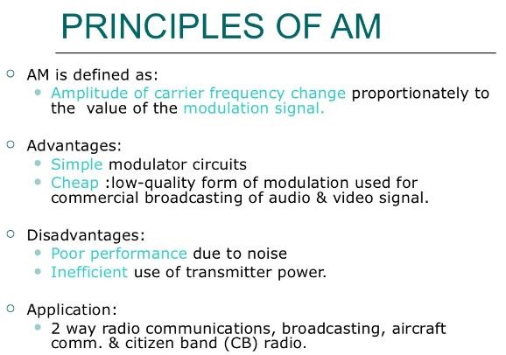

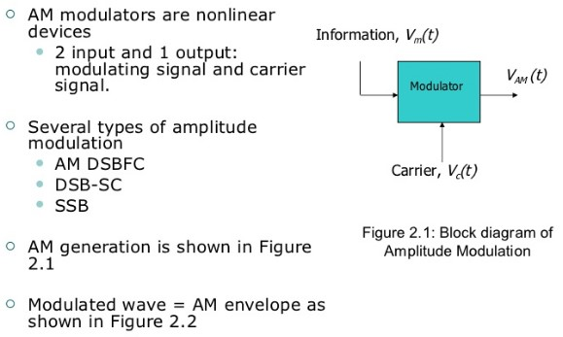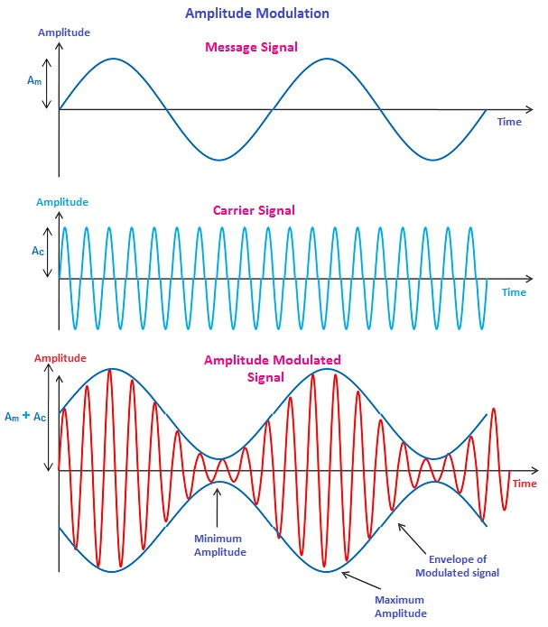

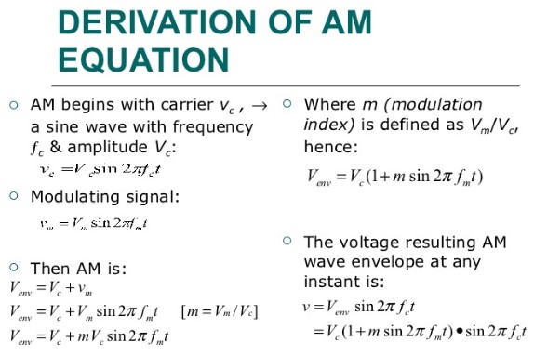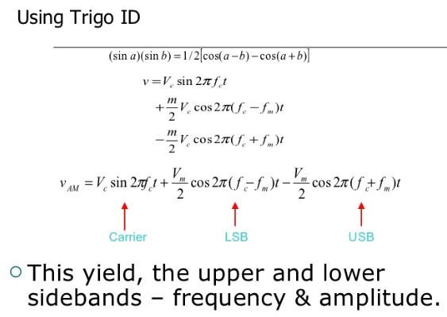

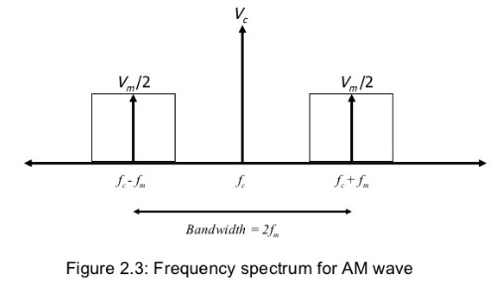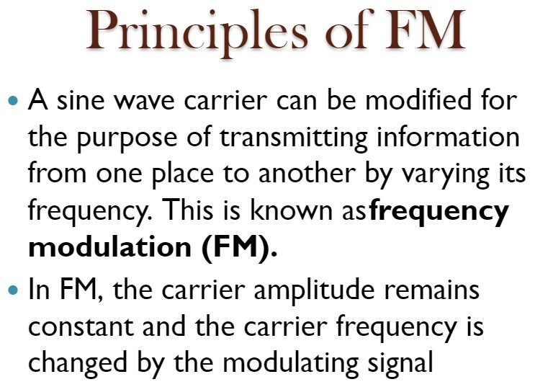

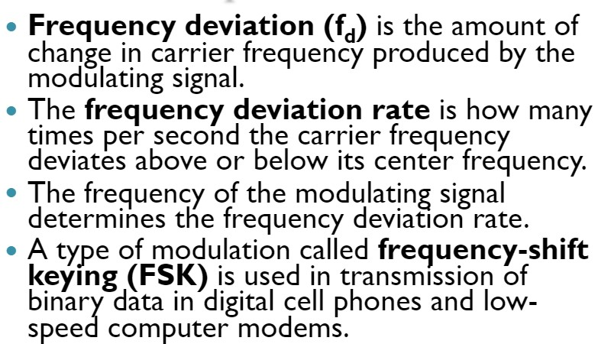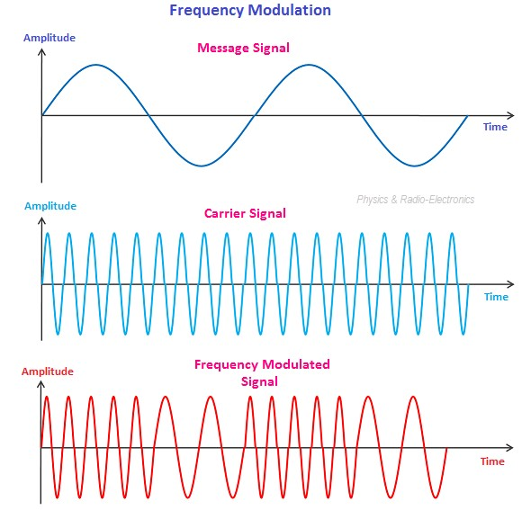

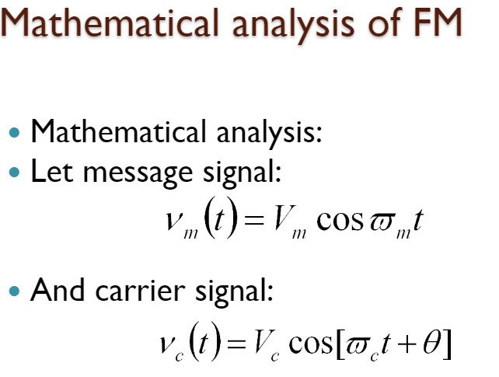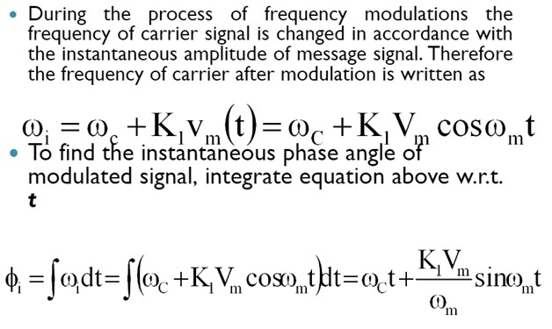

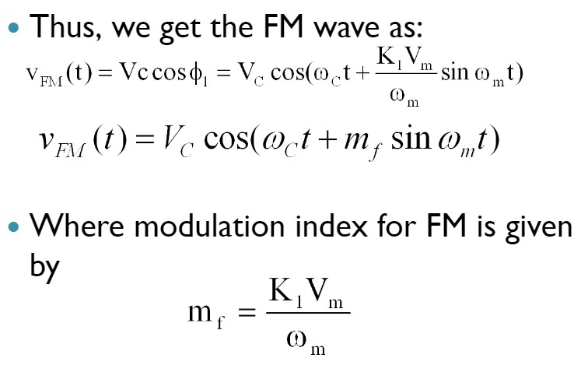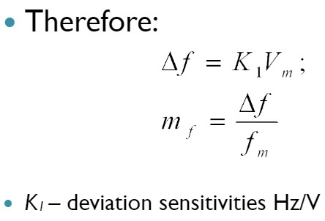

FREQUENCY BAND USED FOR VARIOUS COMMUNICATION
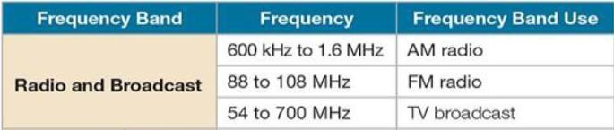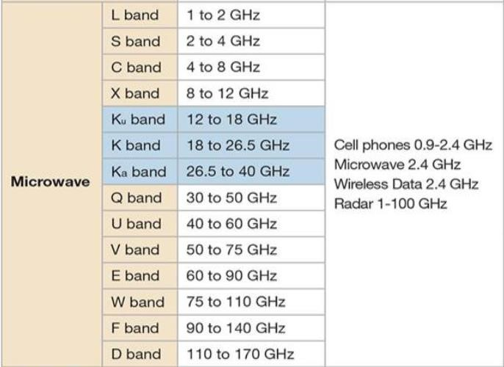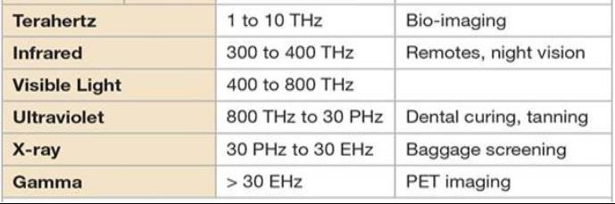

SUPER HETERODYNE RECEIVER
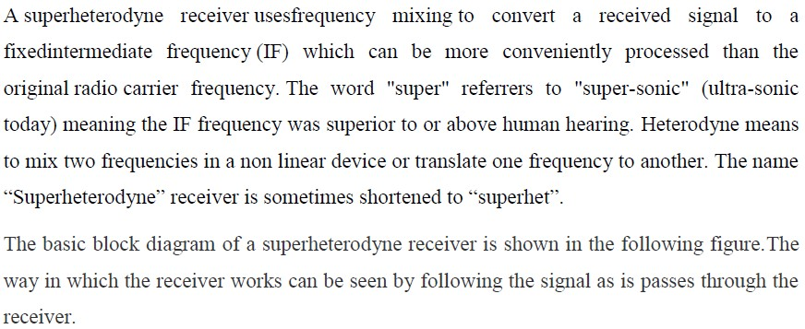
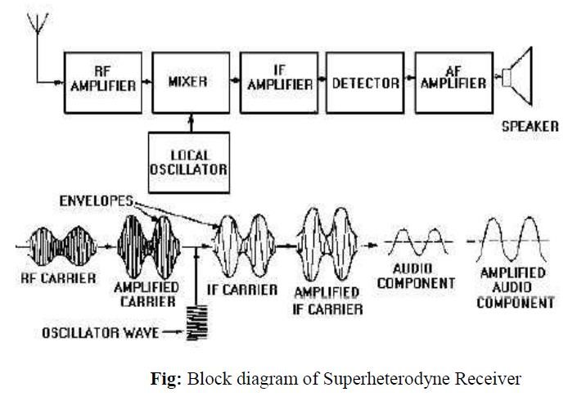

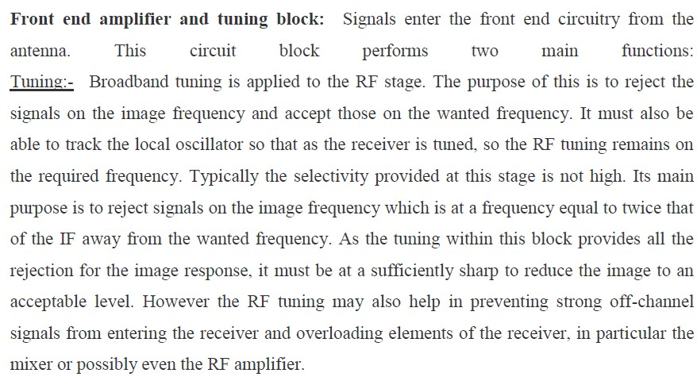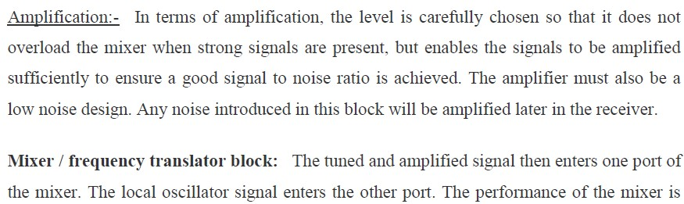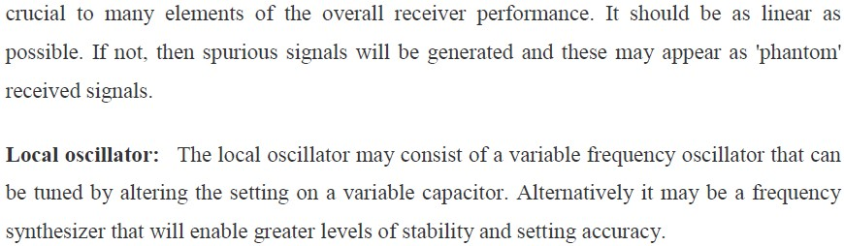

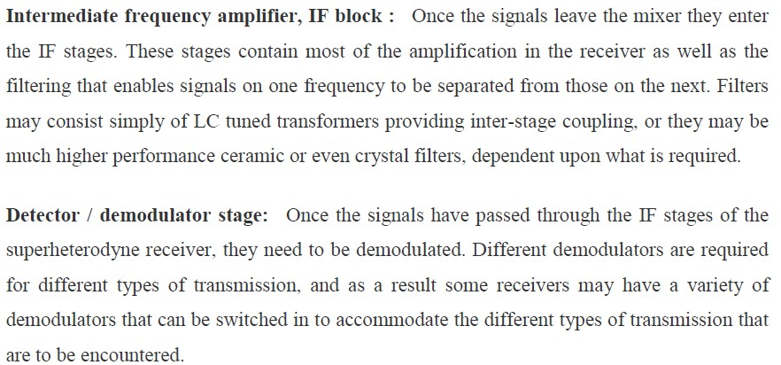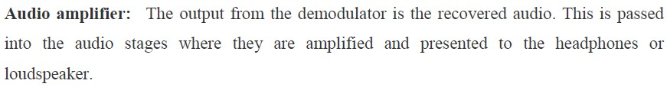

PRINCIPLE OF ANTENNA – RADIATION FROM ACCELERATED CHARGE

Antenna is a source or radiator of Electromagnetic waves or a sensor of Electromagnetic waves. It is a transition device or transducer between a guided wave and a free space wave or vice versa. It is also an electrical conductor or system of conductors that radiates EM energy into or collects EM energy from free space. Antennas function by transmitting or receiving electromagnetic (EM) waves. Examples of these electromagnetic waves include the light from the sun and the waves received by your cell phone or radio. Your eyes are basically "receiving antennas" that pick up electromagnetic waves that are of a particular frequency. The colors that you see (red, green, blue) are each waves of different frequencies that your eyes can detect. All electromagnetic waves propagate at the same speed in air or in space. This speed (the speed of light) is roughly 671 million miles per hour (1 billion kilometers per hour). This is roughly a million times faster than the speed of sound (which is about 761 miles per hour at sea level). The speed of light will be denoted as c in the equations that follow. We like to use "SI" units in science (length measured in meters, time in seconds, mass in kilograms):

c = 3 x 10⁸ meter/second

Under time varying conditions, Maxwell’s equations predict the radiation of EM energy from current source (or accelerated charge). This happens at all frequencies, but is insignificant as long as the size of the source region is not comparable to the wavelength. While transmission lines are designed to minimize this radiation loss, radiation into free space becomes main purpose in case ofAntennas. The basic principle of radiation is
produced by accelerated charge. The basic equation of radiation is
I L = Q V (Ams⁻¹)
where,
I = Time changing current in Amps/sec
L = Length of the current element in meters
Q = Charge in Coulombs
V = Time changing velocity
Thus time changing current radiates and accelerated charge radiates. For steady state harmonic variation, usually we focus on time changing current. For transients or pulses, we focus on accelerated charge. The radiation is perpendicular to the acceleration and the radiated power is proportional to the square of IL or QV.
Transmission line opened out in a Tapered fashion as Antenna: a). As Transmitting Antenna:
Here the Transmission Line is connected to source or generator at one end. Along the uniform part of the line energy is guided as Plane TEM wave with little loss. Spacing between line is a small fraction of λ. As the line is opened out and the separation between the two lines becomes comparable to λ, it acts like an antenna and launches a free space wave since currents on the transmission line flow out on the antenna but fields associated with them keep on going. From the circuit point of view the antennas appear to the transmission lines as a resistance Rr , called Radiation resistance. b) As Receiving Antenna:
Active radiation by other Antenna or Passive radiation from distant objects raises the apparent temperature of Rr .This has nothing to do with the physical temperature of the antenna itself but is related to the temperature of distant objects that the antenna is looking at. Rr may be thought of as virtual resistance that does not exist physically but is a quantity coupling the antenna to distant regions of space via a virtual transmission line.

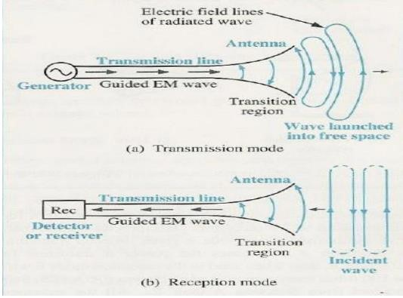
Thus, an antenna is a transition device, or transducer, between a guided wave and a free space wave or vice versa. The antenna is a device which interfaces a circuit and space.

MOBILE COMMUNICATION
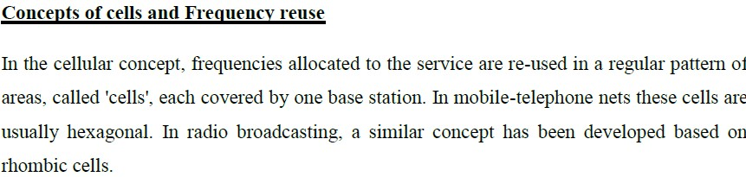
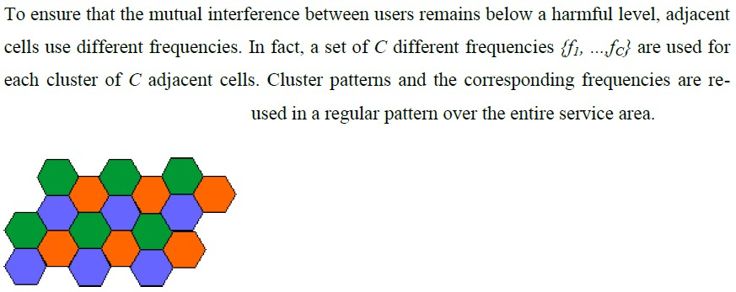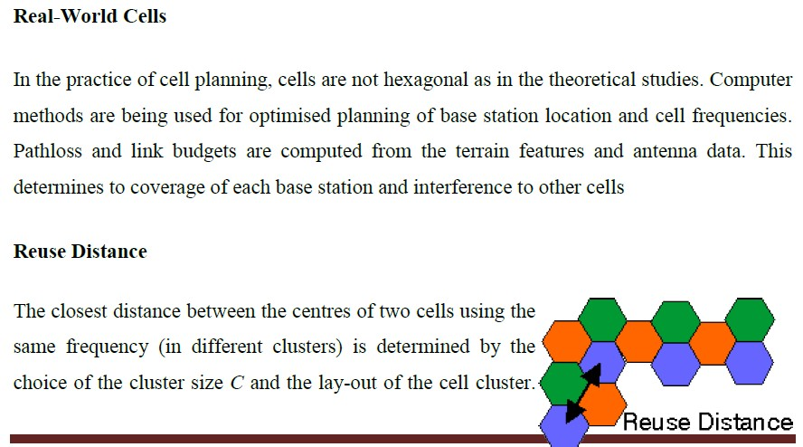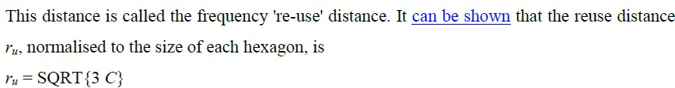

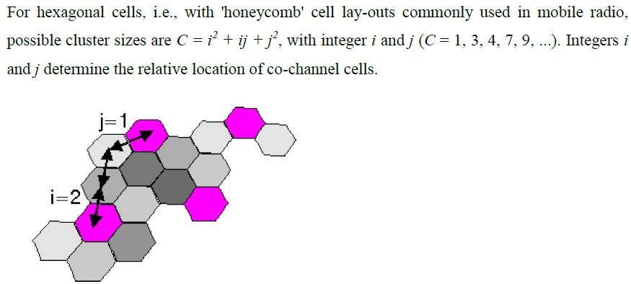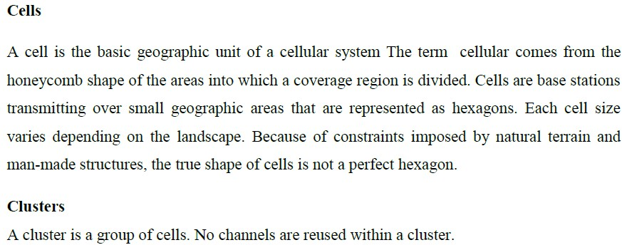
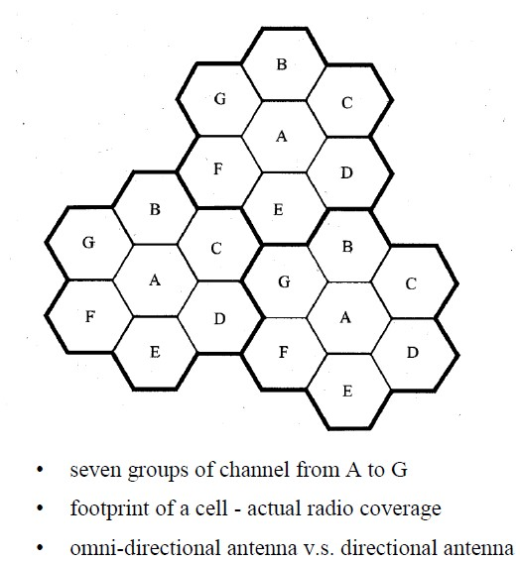

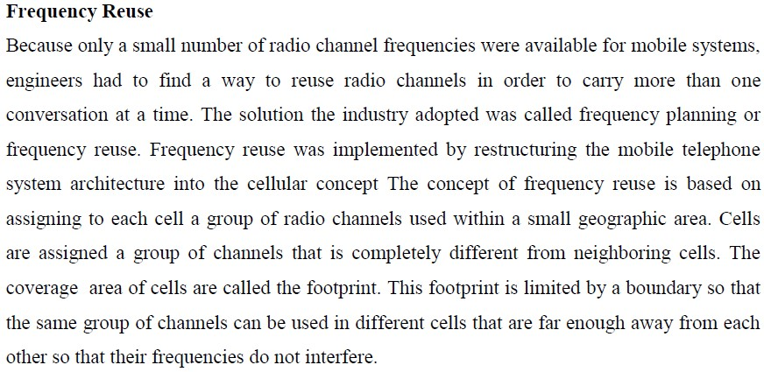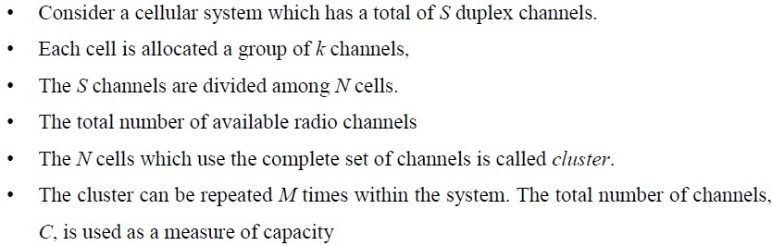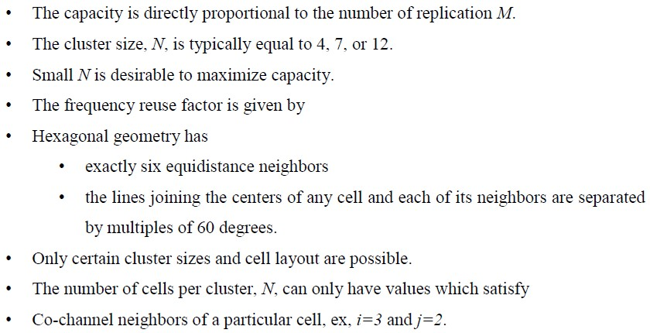

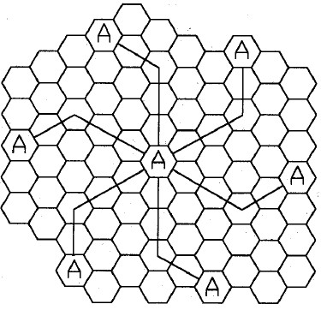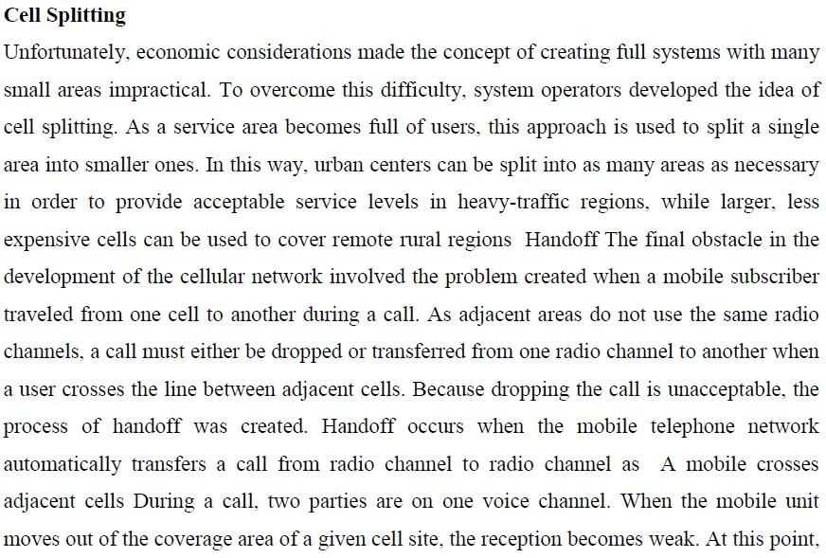

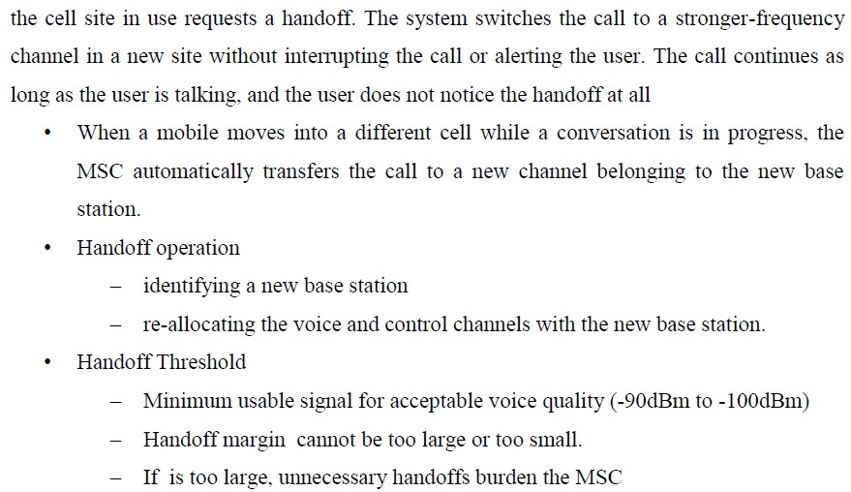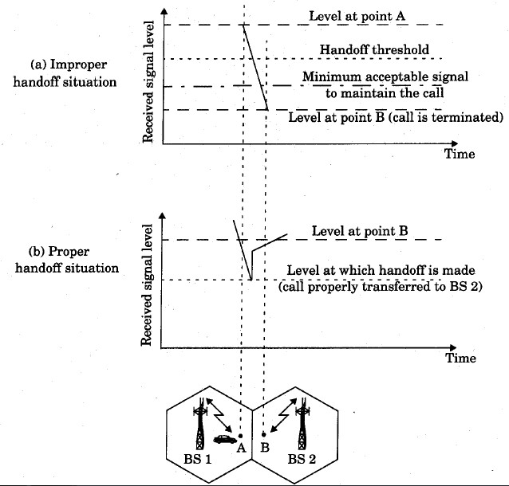

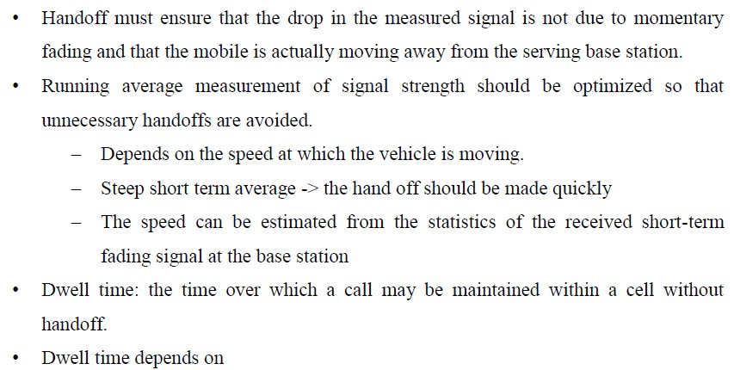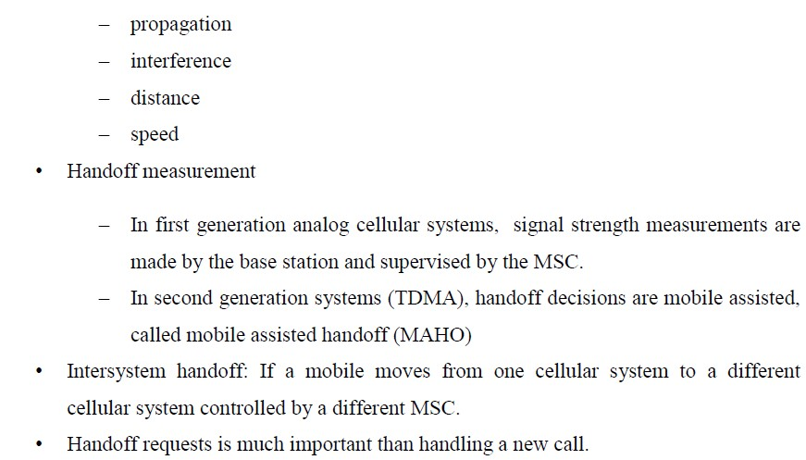

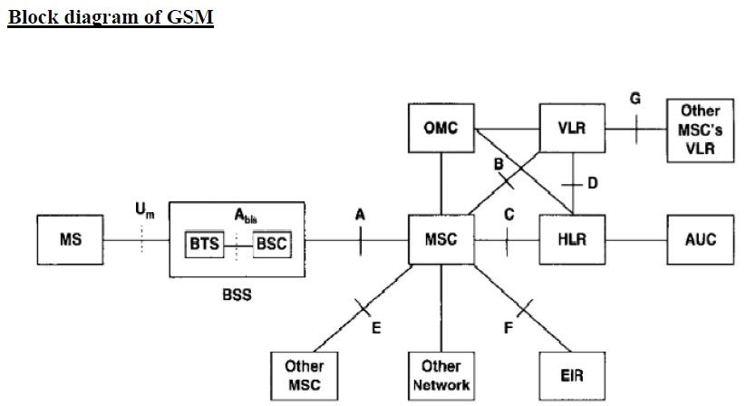

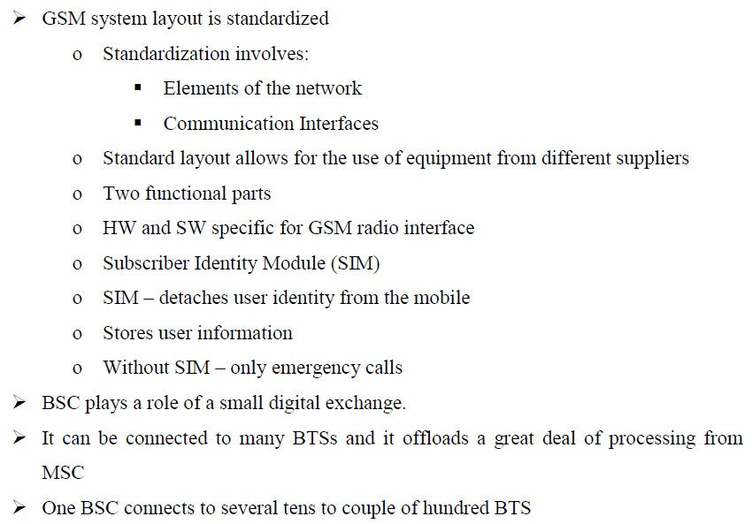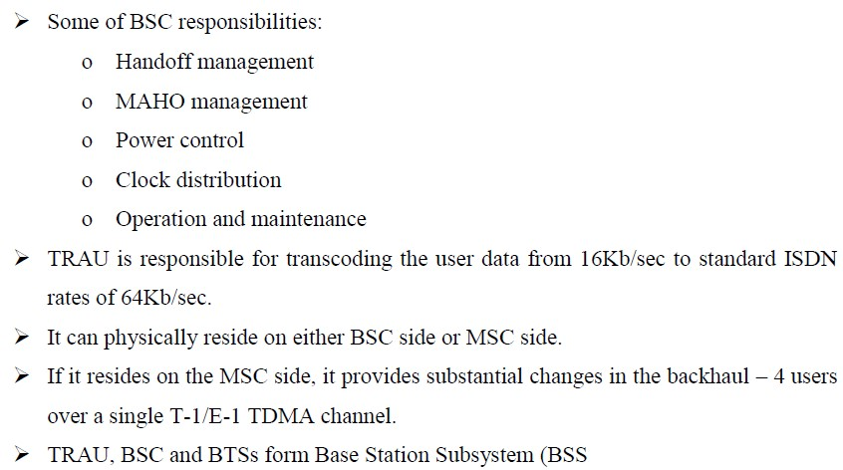

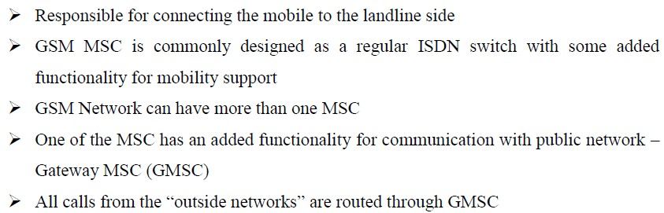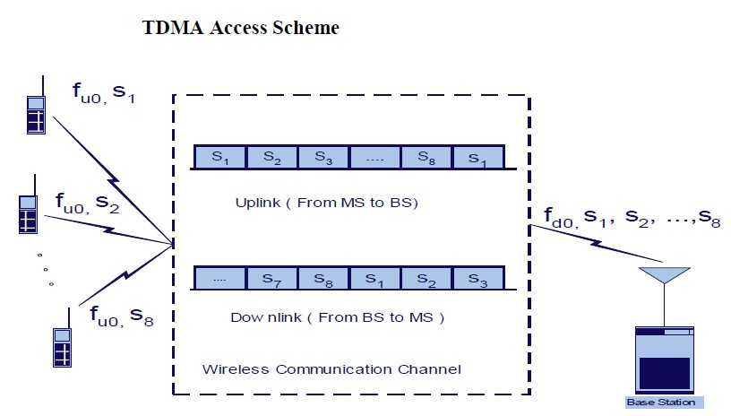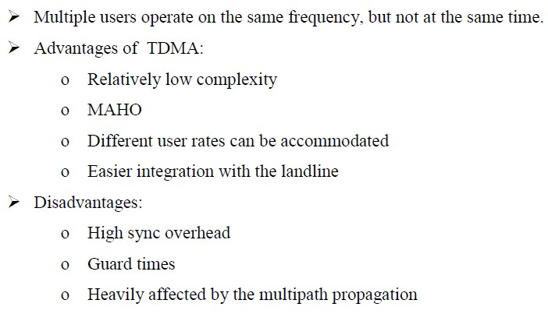

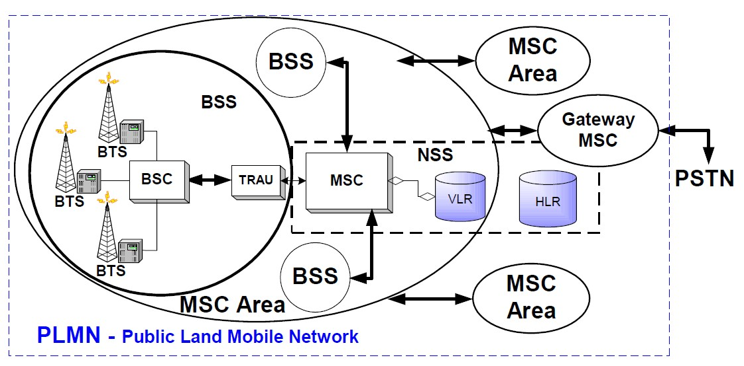

CONTENT BEYOND THE SYLLABUS
Types of Antenna
Some Antenna Types:
Wire Antennas- dipoles, loops and Helical
Aperture Antennas-Horns and reflectors
Array Antennas-Yagi, Log periodic Patch Antennas- Microstrips, PIFAs Basic Antenna Parameters:
A radio antenna may be defined as the structure associated with the region of transition between a guided wave and a free space wave or vice versa.

.
.
.
.

